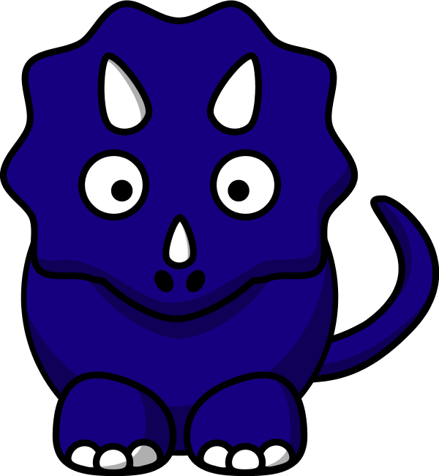

**It’s Storytime for Me!**

My ears are ready to hear.

(CLAP! CLAP!)

My eyes are ready to see.

(CLAP! CLAP!)

My hands, we clap them in my lap.

It’s storytime for me!

**Open! Shut Them!**

Open. Shut them.

Open. Shut them.

Give a little Clap! Clap! Clap!

Open. Shut them.

Open. Shut them.

Put them in your Lap! Lap! Lap!

Creep them Crawl them.

Creep them. Crawl them.

Right up to your Chin! Chin! Chin!

Open wide you little mouth,

And do not let them in.

**Giddy-Up Horsey!**

Giddy-up horsey!

Go downtown.

Giddy-up horsey!

Don’t fall down!

**Dinosaurs**

They used to walk. They used to swim.

They used to fly with a toothy grin.

Some ate plants and some ate meat.

Some walked around on just two feet.

CHORUS

Oh, the dinosaurs! Big as trees!

Dinosaurs! Brains like peas!

Jaws and claws and teeth and bone…

That used to growl, groan, and moan.

Some had feathers. Some had scales,

Spikes, clubs, and whip-like tails

They fought like dragons. The earth sure shook.

The volcanoes sizzled and the lava cooked.

(Chorus)

Tyrannosaurus Rex was a terrible king.

The Stegosaurus’ tail could really swing.

Brachiosaurus liked to stomp.

Trachodon would chew and chomp.

(Chorus)

They roamed the earth,

A hundred million years…

Without worries, cares, or fears.

Then one day they hit the soil…

Now they’re fossils, gas, and oil!

(Chorus) x2

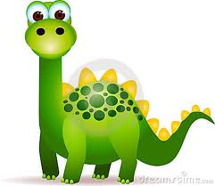

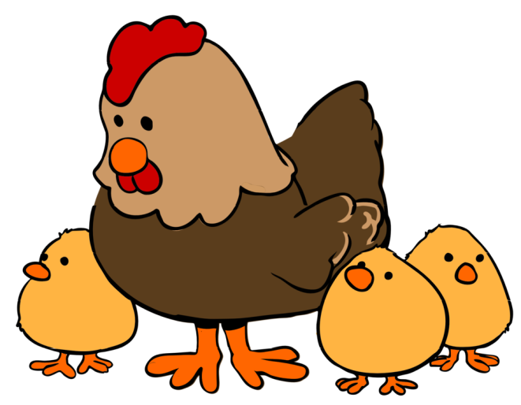

**I Know a Chicken**

Oh, I know a chicken (I know a chicken)

And she laid an egg (and she laid an egg)

Yeah, I know a chicken (I know a chicken)

And she laid an egg (and she laid an egg)

Oh my goodness (oh my goodness)

It’s a shaky egg! (It’s a shaky egg!)

Now shake them fast! Shake ‘em fast!

Shake them fast! Shake ‘em fast!

Shake your eggs! Shake ‘em fast, shake it fast!

(Chorus)

Now shake them slow, you know how it goes,

Shake them slow, because you know how it goes,

And shake them fast! Oh, shake those eggs!

Shake it, shake it, shake it, shake it!

(Chorus)

Now shake them in a circle, round and round.

Don’t you let them touch the ground,

When you shake ‘em round and round,

Now shake them up and down.

Shake ‘em up and down.

You got to shake it up and down.

(Chorus)

**On My Foot There Is a Flea**

On my foot there is a flea,

Now he’s climbing up on me.

Past my belly.

Past my nose.

On my head where my hair grows.

On my head there is a flea,

Now he’s climbing down on me.

Past my nose.

Past my belly.

Tickle! Tickle! Tickle!

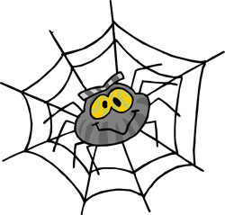

**Itsy Bitsy Spider**

The itsy bitsy spider,

Climbed up the waterspout.

Down came the rain,

And washed the spider out.

Out came the sun,

And dried up all the rain,

And the itsy bitsy spider,

Climbed up the spout again.

**Goodbye to Storytime**

We clap goodbye like this.

We clap goodbye like this.

With our friends at storytime,

We clap goodbye like this!

