Jason Sue

INFO 246-11

Dr. Michelle Chen

18 March 2018

Assignment 3: Storytelling with Information Visualization

1. How was the average speed of the winner changed over the years?

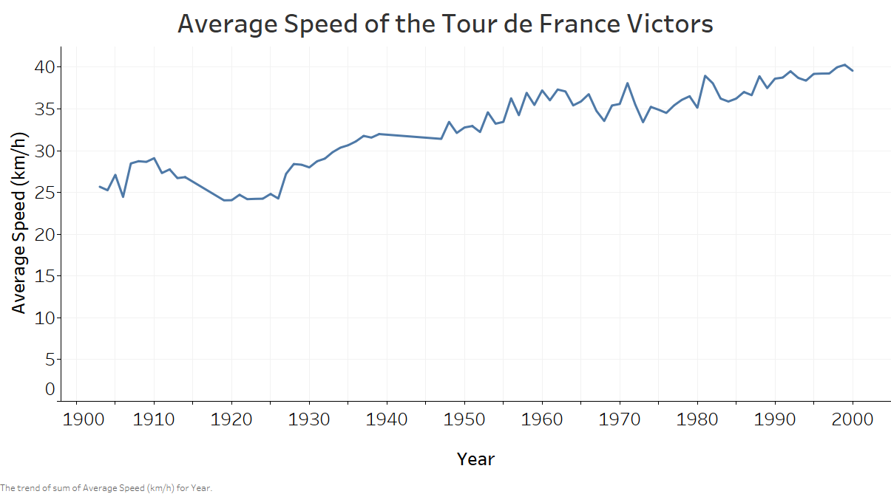

To complete this assignment, I decided to use Tableau. Over the course of the last century, the average speed of the victors in the Tour de France has risen from 25 km/h to 35 km/h. While there is considerable volatility in the trend it is plain to see that that the winners in the most recent decade of the Tour de France are approximately 10 km/h faster than the winners in the Tour de France’s first decade. This simple question was answered through the use of a line graph, which the plotted average speed of the victor over the history of the race. When creating this graph, I had trouble darkening the values and adding an actually visible axis to this line graph. I also had trouble altering the horizontal axis as when you ask to format the horizontal axis that if opens up the controls for the vertical axis. I also experienced difficulty in fitting the screenshots on a letter-sized page. To avoid this “Chart Junk,” I instead used exported PNGs.

2.What country had the most occurrences of its riders finishing first and second place in the same

year?

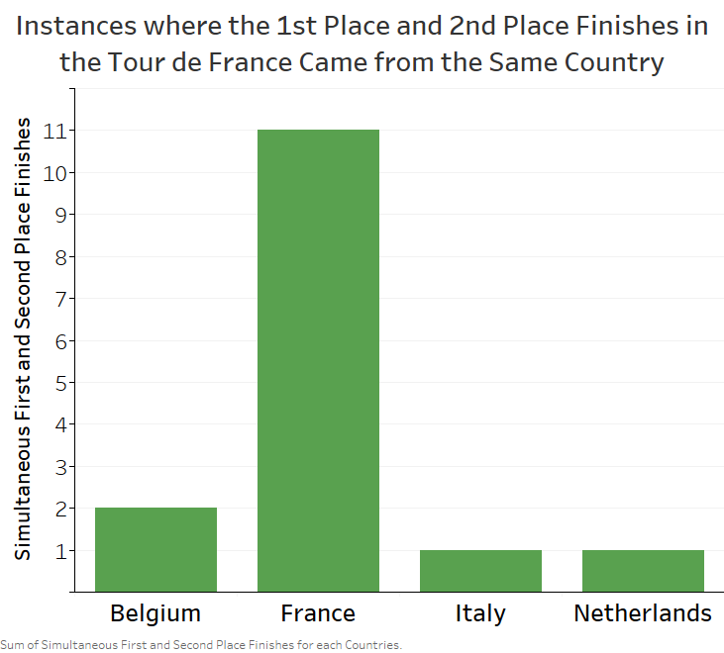

As shown in the above bar graph generated from Tableau, France clearly has the most simultaneous first and second place finishes in the Tour de France. The next closest country is Belgium which can claim to have achieved such a feat twice. The most difficut part of building this graphic was by manipulating the data to generate the result. I used Excel and used an IF command to identify the number of times for each country that this particular feat was accomplished. I then created a small chart of which the above bar graph is the visualization of the result. The same problems in controlling creating axis and darkening the text plagued in this question, but by the end of the third question I was getting the hang of these controls.

3. Characterize how different countries have dominated the world tour.

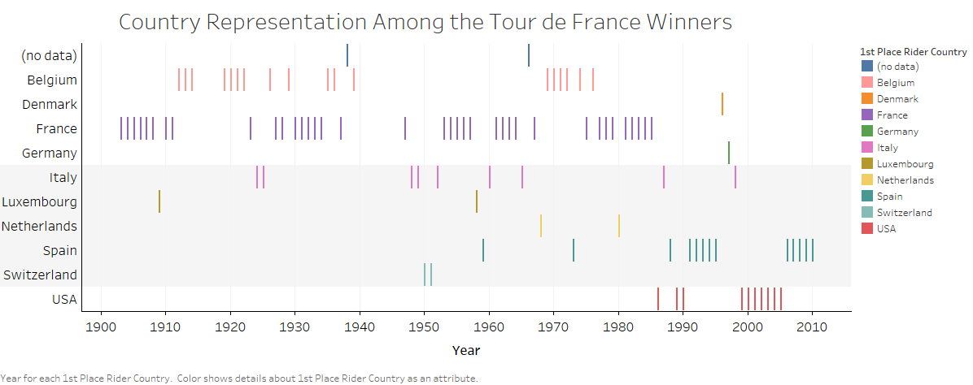

From the beginning of the Tour de France and until 1990, Belgium and France dominated the race, after that though the United States and Spain have dominated the Tour de France over the last two decades. When it comes to establishing which country dominates the Tour de France, it is a question of how many Tour de France victories a specific country can claim. To completely answer the question, I need to consider victories overall and then track those victories across the history of the Tour de France. When considering the first part I thought of using a bar chart, but to help get comfortable with the different types of visualizations I attempted to use a treemap. Unfortunately, I was unable to get Tableau to recognize the aggregate instances of each country in the First Place Rider Country variable. Fortunately, I was more successful in answering the second prong of the question in plotting victories over the course of time using what Tableau refers to as a Gantt Graph. I recognize that a proper Gantt graph displays events over a period of time instead of the singular instances. I am unsure of the name for this type of chart, but this frequency chart answers the question on which countries dominated the Tour de France. Despite my failure to generate either a bar graph or treemap, it is easy to see that France can still claim the most Tour de France victories. To answer this question, color selection was particularly troublesome. I hated relying on the color palettes provided by Tableau. I would have preferred to have bolder colors. In one case, I was unable to pinpoint the color of “Crayola Red.”