Topic 3: Searching, Part 2
Part 2: Using/comparing international search engines
Google may be ubiquitous, but there are many other search engines to choose from! Please look at the following articles for search engines to use:
10 alternate search engines to look at internationally (Links to an external site.)
Alternatives to Google in Europe (Links to an external site.)
International search engines (Links to an external site.)
Search engine colossus: international directory of search engines (Links to an external site.)
- Choose a topic (it does not need to be related to this course) that you'd like to search
- Choose at least 2 (or more) international search engines (NOTE: you may need to have your browser translate the pages)
- Create a query and run the search on each search engine
- Discuss the results – here are some things you might want to address:
-Were the results relevant?
-Were the results diverse?
-Were the results what you were expecting (why or why not)?
-User experience: what difficulties did you experience (if any)?
See the Discussion Expectations and the Discussion Participation Rubric for info about posts/grad


Image representing the 2020 Summer Olympics in Tokyo, Japan
Foreign search engines make for an intriguing topic for the field of Information Science. On several occasions I have had difficulty with communicating with patrons who did not speak English. When browsing the World Wide Web, it is a truly rare occurrence for myself to stumble upon a webpage written in another language. I often use search engines to sate my curiosity; and at the time of this assignment, I was curious about the 2020 Summer Olympics. Brazil hosted the 2016 Summer Olympics in the city of Rio de Janeiro. I thought that it would be interesting to see how Brazil regarded the prospect of Tokyo, Japan hosting the 2020 Summer Olympics. I selected a Brazilian search engine to help me answer this question. With a requirement of this assignment to pick two foreign web browsers, I decided that it would be appropriate to select a Japanese search engine as my other choice. When selecting search engines, I attempted to select search engines that I did not recognize to limit the influence of American-based companies. Unfortunately, the lack of results from these foreign search engines forced me to select American-based search engines or foreign versions of American-based search engines. To help navigate the results, I used the Chrome web browser to translate webpages the used foreign languages.
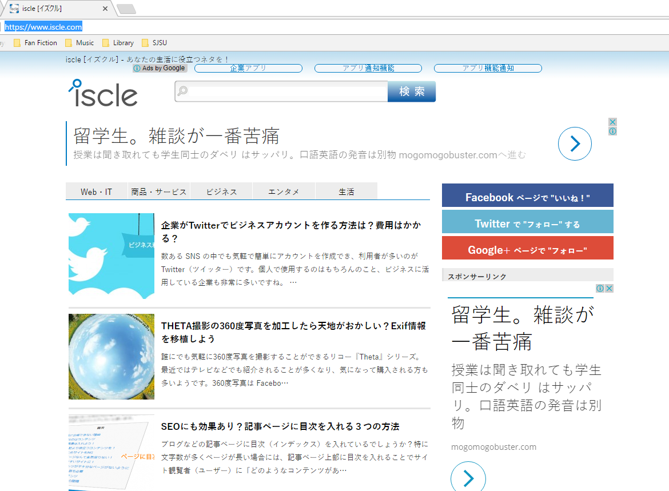
Image of Iscle search engine
I began my searching with the Japanese search engines. I selected the Iscle search engine at https://www.iscle.com for my initial search. When using the unquoted query “summer olympics 2020,” the Iscle search engine failed to retrieve any results.
After retrieving no results, I had the query “summer olympics 2020” translated into Japanese. Google translate generated “2020年夏季オリンピック.” Unfortunately, the Iscle search engine also failed to retrieve any results for this query. From a list of Japanese search engines http://www.searchenginecolossus.com/Japan.html, I selected Ask.com. Unfortunately, I did not recognize at the time that this was not a foreign version of the Ask search engine and simply the same version that I used in the United States. When entering in the unquoted query “summer olympics 2020,” the first result was a collection of four links and a photograph of a male swimmer in what appears to be a butterfly stoke.
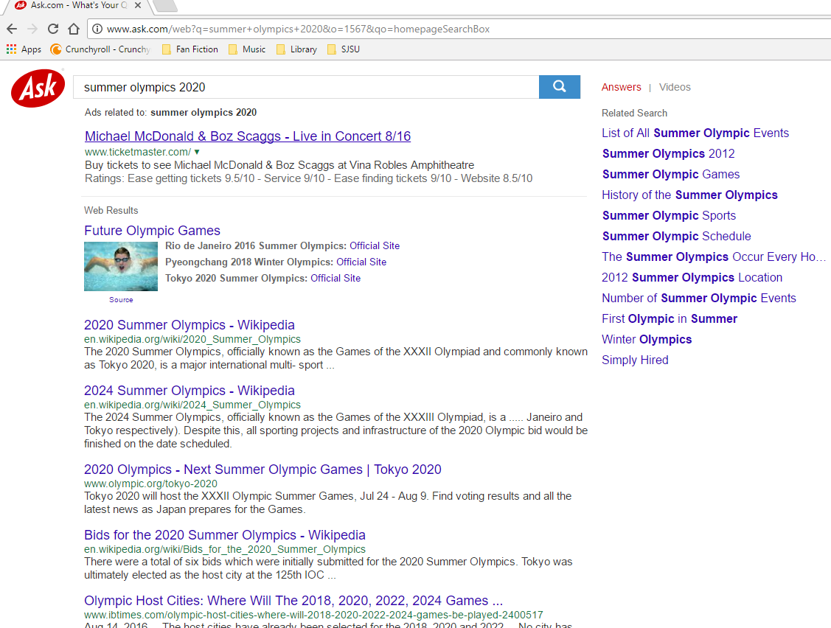
Image of Ask “summer olympics 2020” result
The top link took the user to https://www.olympic.org/olympic-games. This webpage featured the most recent Olympic Games in 2016 Rio de Janeiro and links to the webpages of past and future Olympic Games. Returning back to the Ask search engine’s first result, the three other links led to the official sites of Rio de Janeiro 2016 Summer Olympics, the Pyeongchang 2018 Winter Olympics, and the Tokyo 2020 Summer Olympics respectively. The image also functioned as a link to a website. The website that the image led to seemed to be of a dubious nature; and as a measure of protection for my computer, I quickly browsed away from that page. The next two highest results—as well as the fifth highest ranked result—from the Ask search engine for the unquoted query “summer olympics 2020” were from Wikipedia. The three articles in order of rank featured the Wikipedia pages for the 2020 and 2024 Olympics as well as the Wikipedia page for the bidding process for the 2020 Olympics. In between these retrievals of Wikipedia was the redundant of the official 2020 Summer Olympic webpage. After these results, Ask.com retrieved webpages from various news and sports media websites that discussed the Tokyo Olympic Games. These retrievals include the International Business Times, SB Nation, The Huffington Post, FOX Sports, and Metro (from the United Kingdom). I was largely unsatisfied with these results coming from American websites. So in accordance with the guidelines of the assignment I tried the unquoted query “2020年夏季オリンピック.”
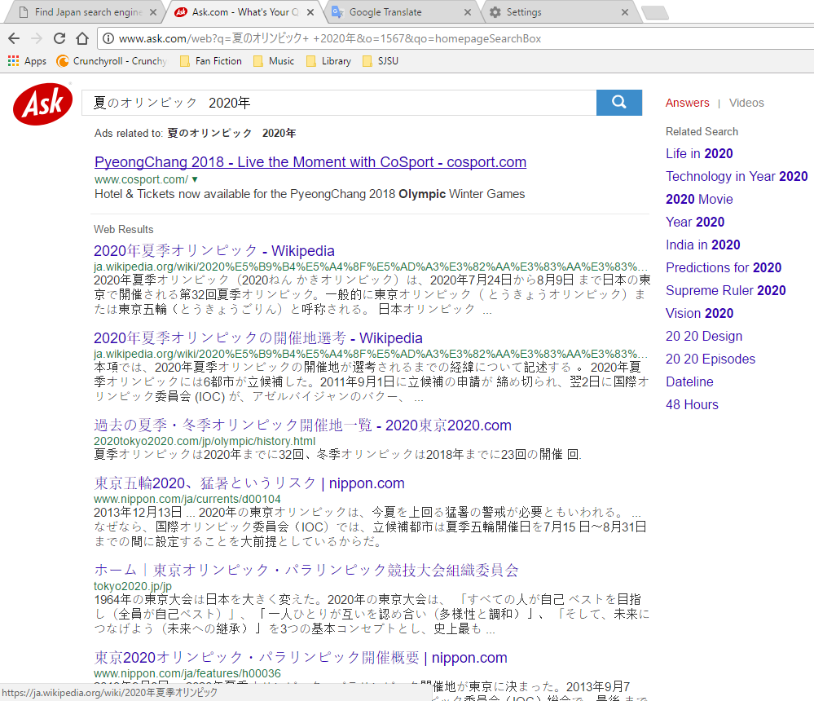
Image of Ask “2020年夏季オリンピック” result
All the resulting retrievals by the Ask search engine for the unquoted query “2020年夏季オリンピック,” were written in Japanese. Without understanding a word, I immediately identified one way in which these retrievals were more diverse than their English query counterparts. The retrievals included a video from Japan’s YouTube website. After translating the results into English, I was able to determine that with the exception of the YouTube video that these results consisted of Wikipedia pages from the Japanese Wikipedia website, official pages to the 2020 Tokyo Summer Olympic Games, and articles from the Japanese news media that are relevant to the 2020 Olympic Games. Sources of these articles included Nikkei (business website), Naver, Nippon, and Reuters Japan. The Ask search engine’s ranking algorithm for both the English query and its Japanese translation ranked Wikipedia pages more highly than official websites who were in turn ranked more highly than news articles.

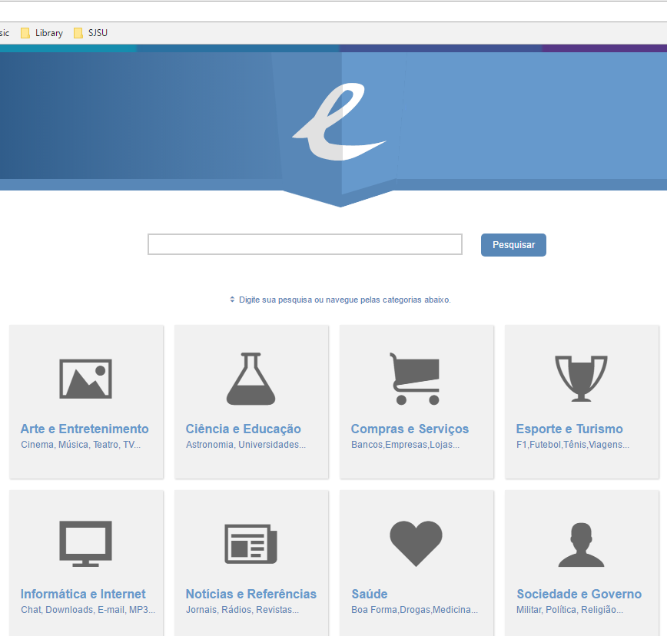
Image of the Exploora search engine
For the Portuguese search engine, I initially selected Exploora at http://www.exploora.com. Unfortunately, the search engine returned no results for the unquoted query “summer olympics 2020” or the Portuguese translation (provided by Google Translate) “Jogos Olímpicos de Verão 2020.” Not to be deterred, I selected the Brazilian Yahoo! search engine for this assignment.

For the unquoted query “summer olympics 2020,” the Yahoo! Brasil (intentional spelling of Brazil) search engine retrieved results written in English. In addition to links to Wikipedia webpages and official websites, Yahoo! Brasil retrieved a link to a mapping website, a humor website, the puns.com, a collection of images, news media articles, as well as, the official Facebook page for Summer Olympic Games 2020. It should be noted that similar to the Ask search engine, Yahoo! Brasil’s ranking algorithm gave Wikipedia webpages a higher ranking than official websites, and that official websites were ranked more highly than the news media.

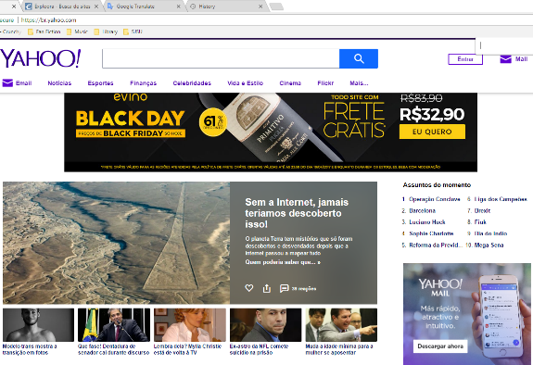
Image of the Yahoo! Brasil search engine

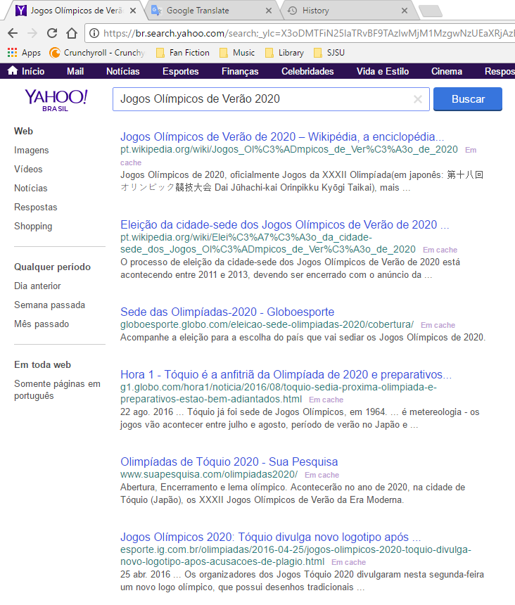
Image of the Yahoo! Brasil search engine results for “Jogos Olímpicos de Verão 2020”
For the unquoted query “Jogos Olímpicos de Verão 2020,” the Yahoo! Brasil search engine retrieved webpages written primarily in the Portuguese language. There were no images or videos in the retrieval results making this the least diverse collection of results for this assignment. Interestingly, the translation of the Portuguese document surrogates (provided by the Chrome web browser) into English, left the few Japanese characters untranslated. The highest ranked results for “Jogos Olímpicos de Verão 2020” came from the Portuguese vision of Wikipedia. This was followed by several articles by the sports media and several articles by the news media. Of some note is the lack of retrieval of any official Olympic webpages.
There were only a few retrievals that were irrelevant to the topic of the 2020 Tokyo Summer Olympic Games. And if those retrievals were irrelevant then, they still referred to other Olympic games. The lack of diversity from the Portuguese language results suggests that the Portuguese World Wide Web is less developed than either their Japanese or English counterparts. In terms of user experience, the most troublesome part of this assignment was the language barrier. It felt like the language barrier had handicapped my ability to determine why the Iscle search engine and why the Exploora search engine could not retrieve any results relevant to the 2020 Sumner Olympics; but as a whole, obtaining translations of foreign text from the Chrome web browser was trouble free.

References
http://www.ask.com/?o=1567
http://www.exploora
https://br.yahoo.com/
https://translate.google.com/#en/ja/summer%20olympics%202020
https://www.iscls.com/
https://www.olympic.org/olympic-games.

