***Gillis Branch Library***

***Mobile Printing***

With our new MobilePrint Service™, you can use your personal computer or mobile device to print to the library’s printers from anywhere. Simply submit documents for printing, and come to the Gillis Library to release, pay, and pick up your document using your email address.

**Method 1—Print from home, work, or anywhere through the Internet:**

* 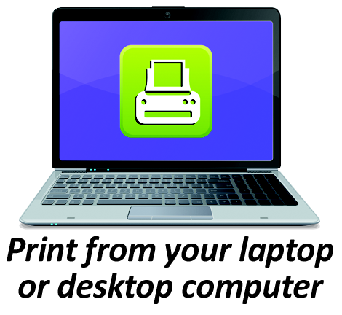Begin by visiting <https://www.printeron.net/fcpl/gillis>
* Select the printer and enter your email address.
* Browse your computer to find and select the file you wish to print.
* Click the green print icon (you will see the status of your print job and a reference number).
* At the Print Release Station in the library, select “Print Your Document”.
* Enter the email address you supplied, and select the OK button.
* Select your print job(s), and pay for your print(s).

Your print job will be printed!

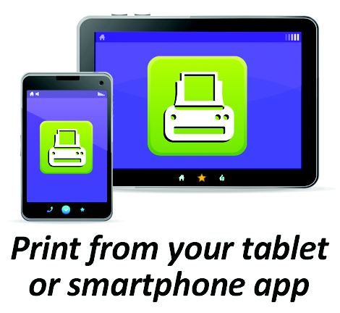**Method 2—Print from a tablet or smartphone app:**

* Visit your device’s ‘store’ for apps. Install and launch the PrinterOn App.
* Click “No printer selected”.
* Click “Search”. Search for Fresno Public Library.
* Find Gillis and click Black and White or Color Printer and save.
* To print:
  + Documents: when viewing the document, click in the upper right corner, and upload the document to the PrinterOn App.
  + Photos from your phone: open the app, click on “photo” and select a photo to print.
  + Select the printer, and click the print icon.
  + Enter an email address, and click on the check mark (you will receive a notice that the job started and shortly after another message stating “Job Success”).
  + At the Print Release Station in the library, select “Print Your Document”.
  + Enter the email address you supplied, and select the OK button.
  + Select your print job(s), and pay for your print(s).

Your print job will be printed!

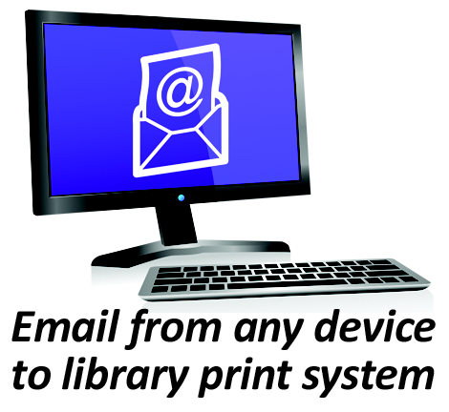**Method 3—Email attachments directly to the library print system:**

* Email from any device directly to the library’s print system at   
  [fcpl-gillis-bw@printspots.com](mailto:fcpl-gillis-bw@printspots.com)

[fcpl-gillis-color@printspots.com](mailto:fcpl-gillis-color@printspots.com)

* At the Print Release Station in the library, select “Print Your Document”.
* Enter the email address you supplied, and select the OK button.
* Select your print job(s), and pay for your print(s).

Your print job will be printed!