Jason Sue

INFO 210-11

Dr. Johanna Tunon

Fall 2018

**Mini Activity 8: Finding Facts**

**#1 Calendar/Events/Dates**

(a) Check a library print or online traditional reference source that tracks events such as *Chase’s Calendar of Events*  *Chase's Calendar of Events*. Locate an event. For example, you might want to look for an event that took place on or near your birthday.

(b) Next try using an open-access web tool such as the Google News Archive Search feature, This Day in History ([http://www.history.com/this-day-in-history/ (Links to an external site.)Links to an external site.](http://www.history.com/this-day-in-history/) ), or even Wikipedia. Provide a screenshot of what you found for the same event used in the previous step.

(c) In a sentence or two, compare the quality of the information on event(s) you located using the two tools.

(a) Check a library print or online traditional reference source that tracks events such as Chase’s Calendar of Events Chase's Calendar of Events. Locate an event. For example, you might want to look for an event that took place on or near your birthday.

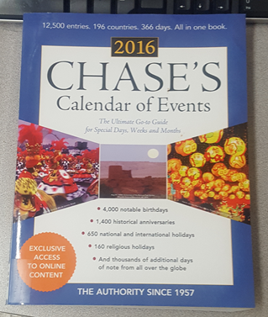Due to my interest in the *Chase’s Calendar of Events,* I decided to use this printed reference resource and my birthdate to locate an event of historical significance. Of most interest to me from the 2016 edition of Chase’s Calendar of Events for September 20 was Billie Jean King’s win in the televised tennis match known as the “Battle of the Sexes” in 1973.

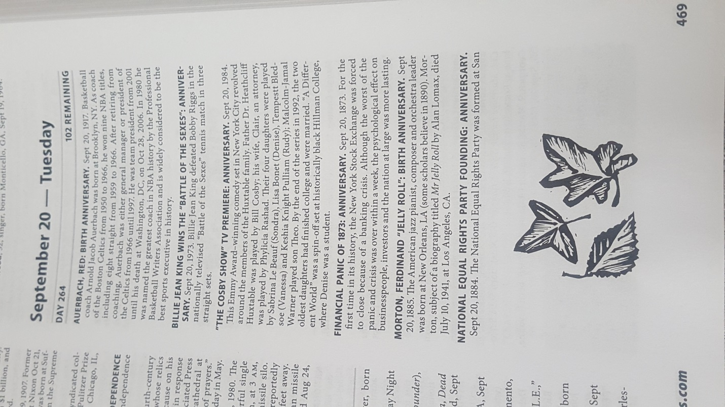

(b) Next try using an open-access web tool such as the Google News Archive Search feature, This Day in History (http://www.history.com/this-day-in-history/ or even Wikipedia. Provide a screenshot of what you found for the same event used in the previous step.

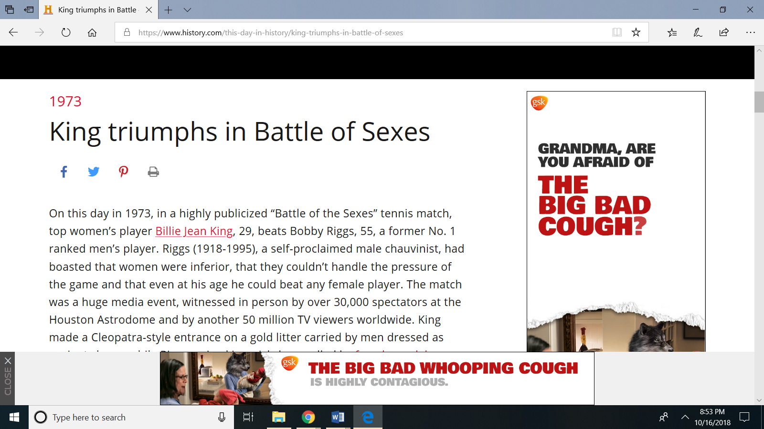

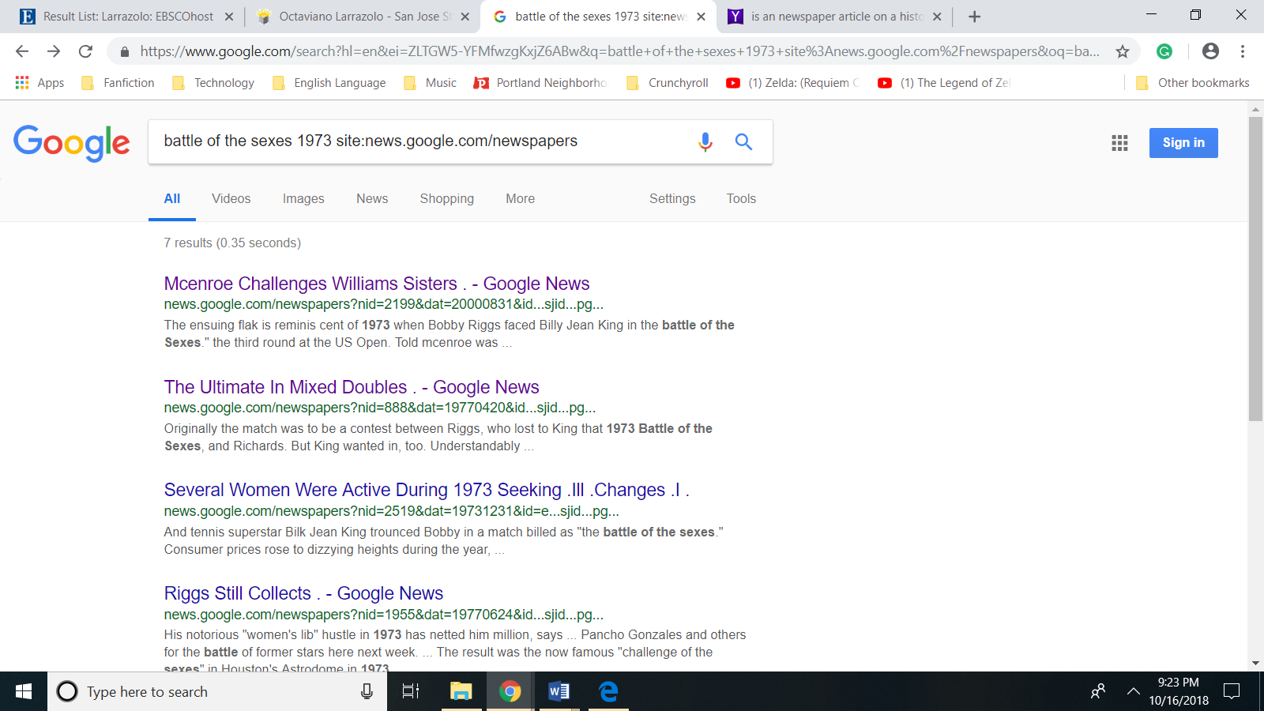

(c) In a sentence or two, compare the quality of the information on event(s) you located using the two tools.

Because my topic—the 1973 Battle of the Sexes—was chosen for its historical significance. History.com’s “This Day in History” for September 20, did feature an article on this event. In fact, it was this day’s lead story. Unfortunately, the information provided was lacking in several areas mostly due to the fact that the article reads like a biography of Billy Jean King and her victory over Bobby Riggs was treated as merely one achievement of many. In particular, this article was short on context making no mention of Bobby Riggs’ first match against Margaret Cook and very one sided provided little form Bobby Rigg’s perspective. Overall, the information delivered in the featured article is clearly retrospective. In contrast newspapers, can provide first hand accounts of events which means, which means that Google News Archive Search is reference source with the potential of retrieving information from primary sources. While I didn’t retrieve a first hand account of the Battle of the Sexes, Google News Archive did provide several primary sources of which the most interesting was the obituary of Bobby Riggs

**#2 Facts about People**

A high school student is doing a research paper on Hispanics in government and found in a Google search that the nation's first elected Hispanic senator was Octaviano Larrazolo. The information came from a reliable government website -- [http://www.senate.gov/artandhistory/history/common/generic/Hispanic_Heritage_Month.htm (Links to an external site.)Links to an external site.](http://www.senate.gov/artandhistory/history/common/generic/Hispanic_Heritage_Month.htm).  However, can you locate two reference resources that confirm that Larrazola is indeed considered a "famous first"?  Print places you can check is *Famous First Facts*and*Famous First Facts about Politics.*or you can try your luck with a variety of online reference tools.  Describe what information you did or did not find about Larrazolo about Larrazolo being the first elected Hispanic/Mexican senator in the reference resources you checked.

To confirm that Octaviano Larrazolo was the first elected Hispanic senator I consulted the sixth edition of famous first facts and. consulted with the sixth edition of *Famous First Facts* and the

Marquis Who's Who. While I was able to retrieve a short inscription on Octaviano Larrazolo, that inscription focused mostly on his time as governor and did not corroborate whether Octaviano Larrzolo was the first elected Hispanic senator. However, the 253 page of *Famous First Facts* does corroborate that fact that Octaviano Larrazolo was the first elected Hispanic senator.

**#3 Local Special Collections vs Online Subscription Databases or Free-Access Digital Archives**

(a) Identify a special print collection or a digital collection available locally in your area or elsewhere.

(b) Use the OAIster subscription database or another appropriate subscription or free-access source such as the National Archive website ([http://www.nara.gov (Links to an external site.)Links to an external site.](http://www.nara.gov/)) or the [Digital Public Library of America (Links to an external site.)Links to an external site.](http://dp.la/) to look for similar resources.

(c) Briefly identify the topic you used and the sources used. Provide a screenshot of your findings or briefly describe them and describe how well your choice of resources did in helping you locate or provide access to the resources you were trying to locate.

(a) Identify a special print collection or a digital collection available locally in your area or elsewhere.

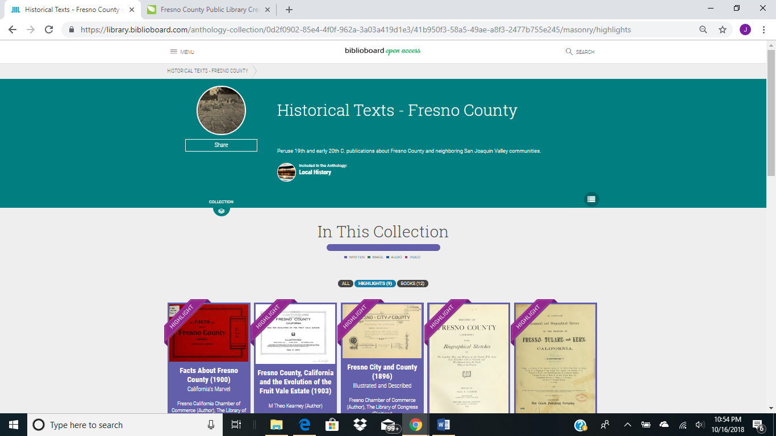

The Fresno County Public Library curates and provides access to a digital collection titled “[Historical Texts – Fresno County](https://library.biblioboard.com/anthology-collection/0d2f0902-85e4-4f0f-962a-3a03a419d1e3/41b950f3-58a5-49ae-a8f3-2477b755e245)”

b) Use the OAIster subscription database or another appropriate subscription or free-access source such as the National Archive website (http://www.nara.gov)or the Digital Public Library of America to look for similar resources.

I searched both the National Archives website and the Digital Public Library of America to find resources similar to the “Historical Texts – Fresno County” collection.

(c) Briefly identify the topic you used and the sources used. Provide a screenshot of your findings or briefly describe them and describe how well your choice of resources did in helping you locate or provide access to the resources you were trying to locate.

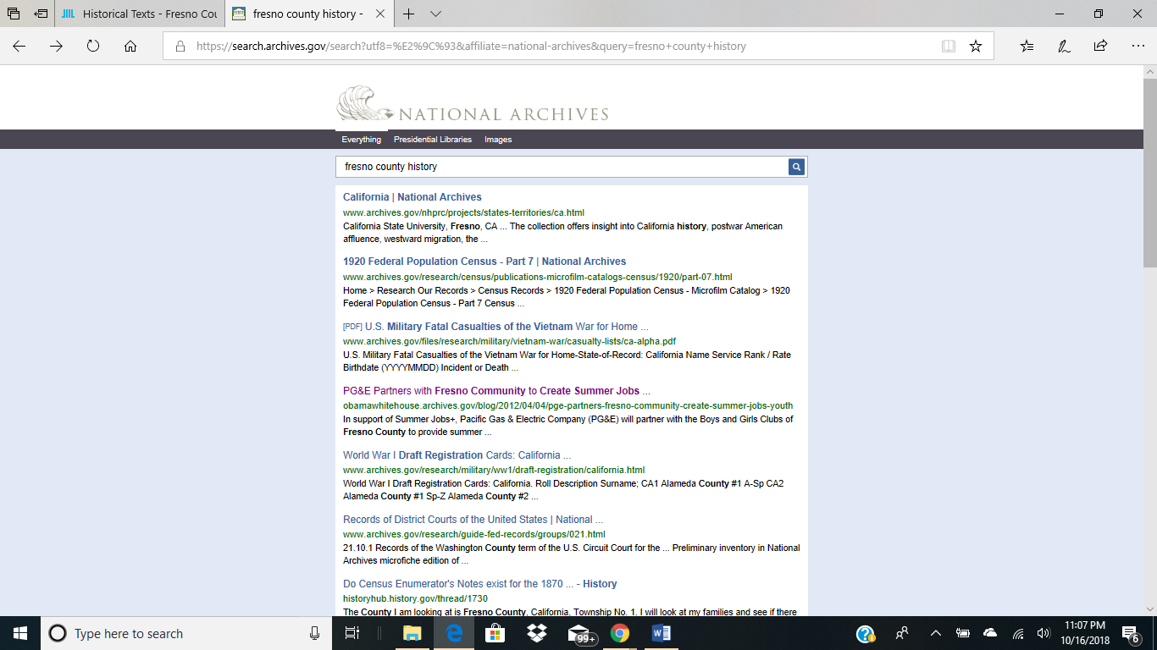

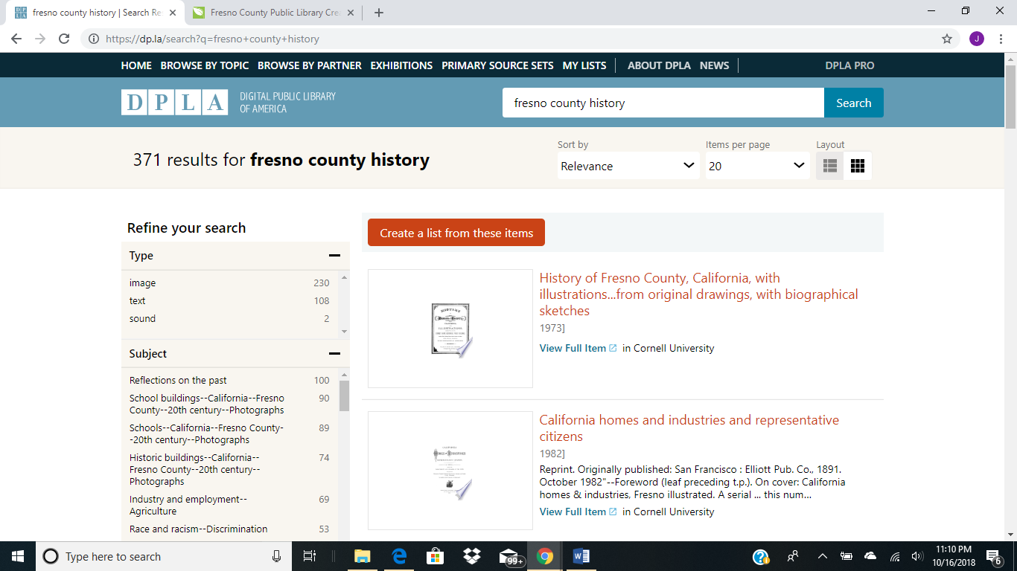

I’ve always been interested in the origins and development of Fresno, the city where I have lived all my life. The Fresno County Public Library and in particular it’s “Historical Texts – Fresno County” collection is a good starting point for research on this topic. To supplement, I attempted to search both the National Archives and the Digital Public Library of America. When rating the accuracy of results, the Digital Public Library of America seems to retrieve less information on current events than the National Archives, but one benefit that the National Archives has over the Digital Public Library is that certain retrieves were whole collections of materials whereas the Digital Public Library indexed resources one by one. As someone who knows very little about the formation of the city of Fresno and the county of Fresno the ability of the National Archives to identify whole collections of relevant items versus having to index items individually is quite useful.

**#4 Finding Training and Homework Help**

The King Library does not have access to Lynda.com, but if you have access locally to Lynda.com, try looking for training for a "soft" topic such as conflict resolution and a technology topic such as screencasting design considerations, web accessibility issues, or how to use a specific software application that would be useful to you as a librarian. (a) Identify the topics selected and (b) provide a screenshot of the training for each of the topics. (c) Briefly describe the pros and cons of Lynda.com.

(a) Identify the topics selected.

The two topics I selected where scheduling and the effective measurement of customer service.

(b) Provide a screenshot of the training for each of the topics.

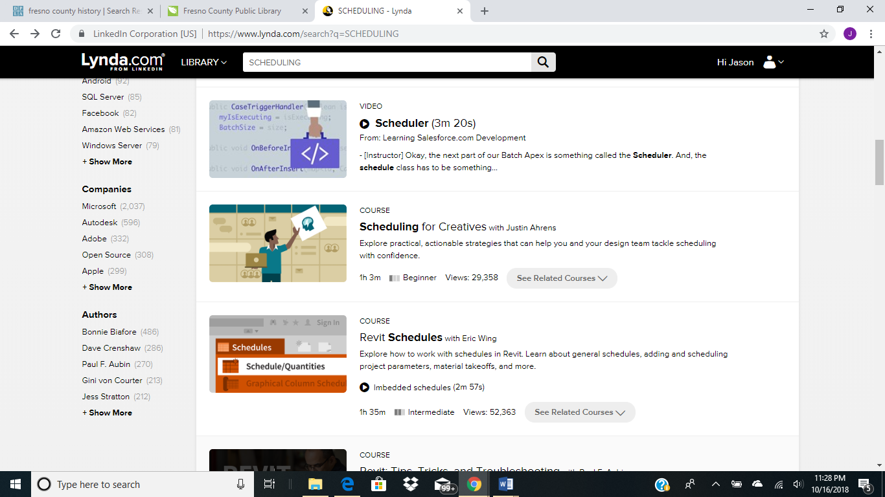

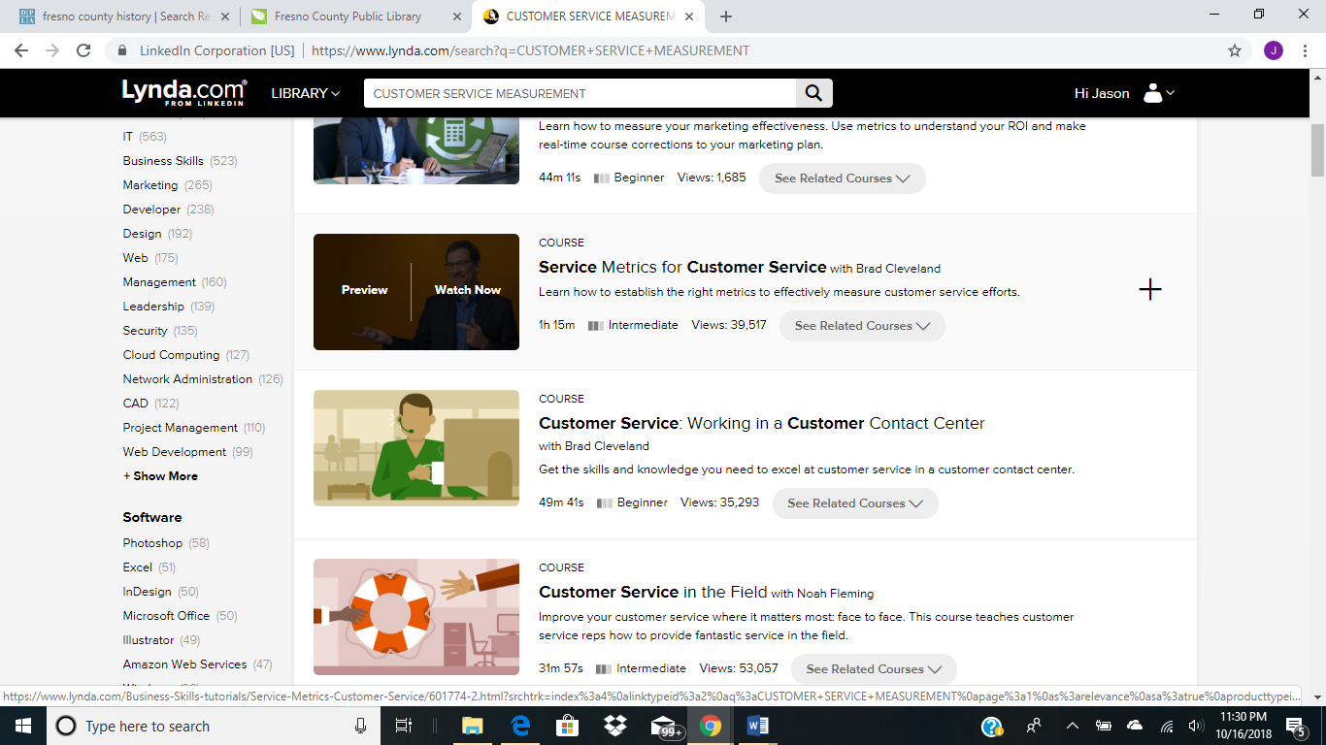

(c) Briefly describe the pros and cons of Lynda.com.

One of the pros of Lynda.com is its expansive range of topics and resources that can accommodate a variety of skill levels and time constraints. Other than the bandwidth that Lynda.com requires, it’s primary detraction is the cost that institutions have to pay to maintain their subscriptions.

**#5 Health Care**

Finding reliable health information for people who do not speak English is frequently a challenge for all types of libraries. [Medline Plus (Links to an external site.)Links to an external site.](https://medlineplus.gov/) is easy to use by the general public, full of accurate information and good advice on everything from surgery videos to health check tools to games, offers help via NIH [online chat (Links to an external site.)Links to an external site.](https://www.nlm.nih.gov/services/nlmchat.html%C2%A0), and is much more reliable than WebMD. Additionally, the information located in Medline Plus can be converted to Spanish, and [selected health information is converted to 60 other languages (Links to an external site.)Links to an external site.](https://medlineplus.gov/languages/languages.html).   
(a) Do a search on a topic of interest. Provide a screenshot and describe your search topic.  
(b) Choose a[language other than Spanish (Links to an external site.)Links to an external site.](https://medlineplus.gov/languages/languages.html), and see what you can find on your topic. Identify the language and briefly describe how useful Medline was in addressing your information need.

(a) Do a search on a topic of interest. Provide a screenshot and describe your search topic.

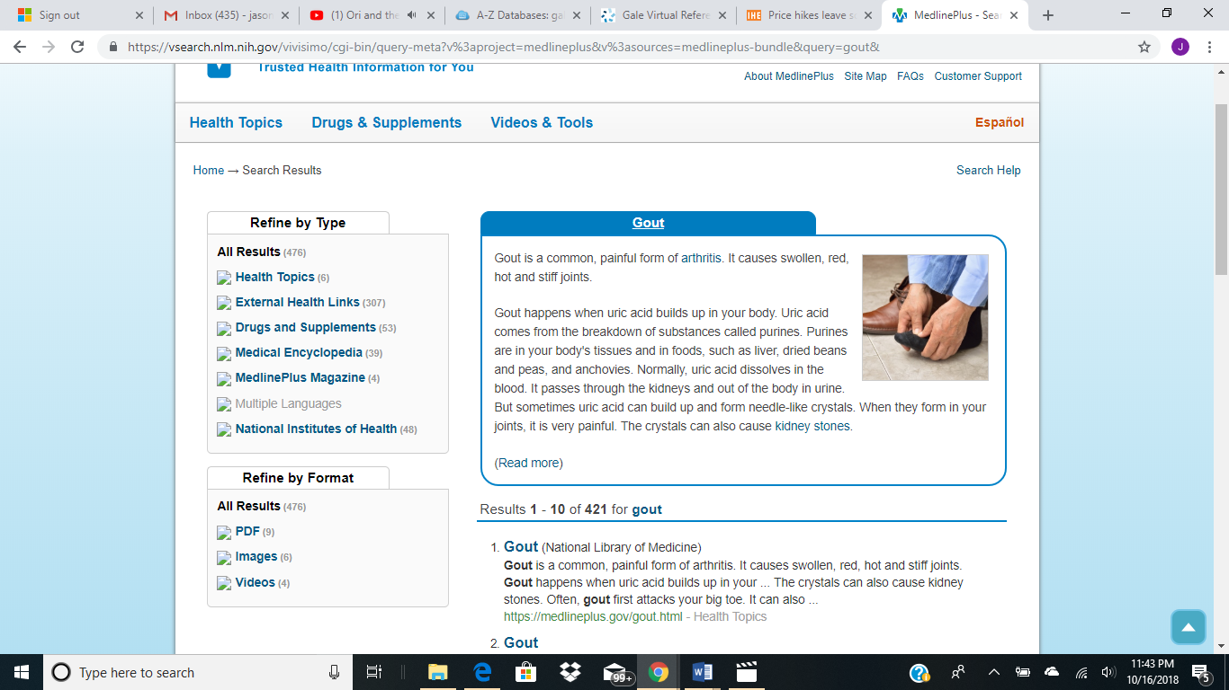

Medline compiled articles from a wide variety of resources to address issues such as diet, genetics, and management of symptoms as related to gout.

(b) Choose a language other than Spanish (Links to an external site.)Links to an external site., and see what you can find on your topic. Identify the language and briefly describe how useful Medline was in addressing your information need.

I chose Cantonese, since it is a language that is spoken by my father although I have failed to pick up this dialect of Chinese. Unfortunately, there were no Cantonese resources relevant to the topic of gout in Medline’s Multiple Language, but this may be more due to its historically low prevalence in mainland China.

**#6 Reference Librarians**

Reference librarians are often the point of contact for patrons who need to locate help with some crisis in their lives so it is important to know about local resources and services that are available in the community. Call your local library to find out what kinds of information they have to help patrons identify and locate community/state/federal support services and/or services offered by not-for-profit organizations.   
(a) Briefly describe how the library makes this information accessible to people in need. It would be better to see what the librarian identified, but if the librarian is not sure how to answer this question, find out if the library has a directory, local web resources identified, or a list of phone numbers that is used to refer patrons for specific services. If no services can be identified, ask about some more specific service provided to low income or special needs people.   
(b) Describe what you learned about how the library provides support for people in need of some kind of social services.

(a) Briefly describe how the library makes this information accessible to people in need. It would be better to see what the librarian identified, but if the librarian is not sure how to answer this question, find out if the library has a directory, local web resources identified, or a list of phone numbers that is used to refer patrons for specific services. If no services can be identified, ask about some more specific service provided to low income or special needs people.

Connecting patrons to resources for low income or with special needs is one of the weaknesses of the Fresno County Public Library. From experience, library assistants learn as they go on what resources are useful and how to connect patrons to the resources they need. When asking the library assistant answering call for the Fig Garden Regional Library, I honestly felt really bad, because I was pressing for a list of phone numbers or contacts for charity that the staffer simply did not have.

(b) Describe what you learned about how the library provides support for people in need of some kind of social services.

I wouldn’t say I learned how the library provides support for people in need of some kind of social service, but I discovered what must be done to provide better service. It seems easy, but there is simply not enough time. Namely, instead of having library assistants be responsible for a wide range of duties, designate a few staffers to specialize in answering reference questions.