Jason Sue

INFO 210-11

Dr. Johanna Tunon

Fall 2018

**Mini Activity 7: Dictionaries, Encyclopedias, Etc.**

**#1 Acronyms or Slang/Regional Terminology**

In the budget fights that took place in February, 2018, Nancy Pelosi called for the budget that gets the most votes to be the one that wins. In congressional parlance this is called the "queen of the hill" rule. You could of course do a quick Google search to see various web and newswire reports that provide definitions, but try using the King Library's OneSearch to see what you can find that would provide a more scholarly/reliable source for defining what is meant in the U.S. House of Representatives rules by the term, "queen of the hill." Provide a screenshot and quick explanation of why you selected your specific source.

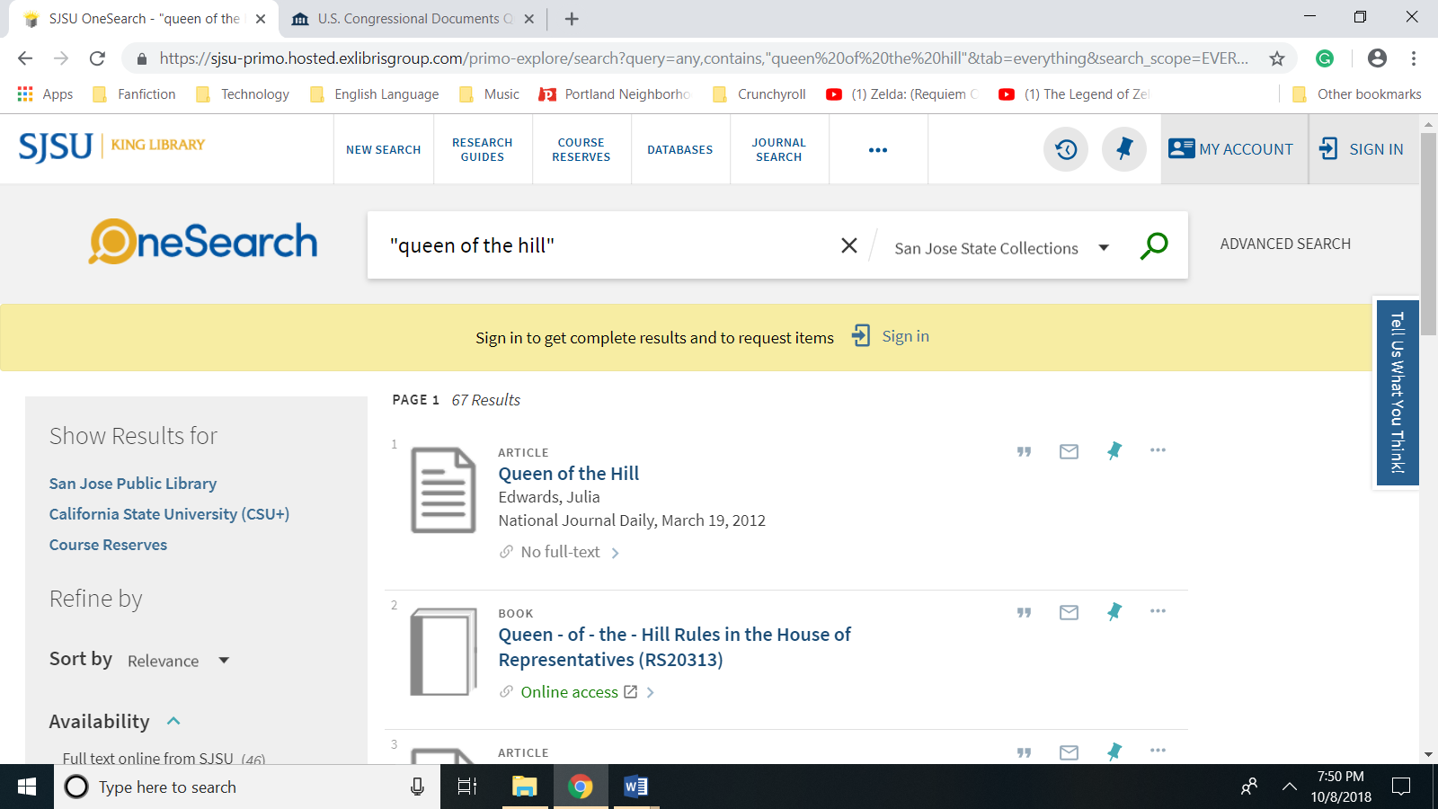

I selected “Queen-of-the-Hill” Rules in the House of Representatives as my source because it comes from HeinOnline’s database of U.S. Congressional Documents and it provides a historical look at the Queen-of-the-Hill rules and how it evolved from the predecessor King-of-the-Hill rules. This short paper not only describes Queen-of-the-Hill as a way of considering amendments where the measure with the greatest support was adopted, but how it improved on the previous King-of-the-Hill where only the most recent alternative measure would be adopted by the House of Representatives.

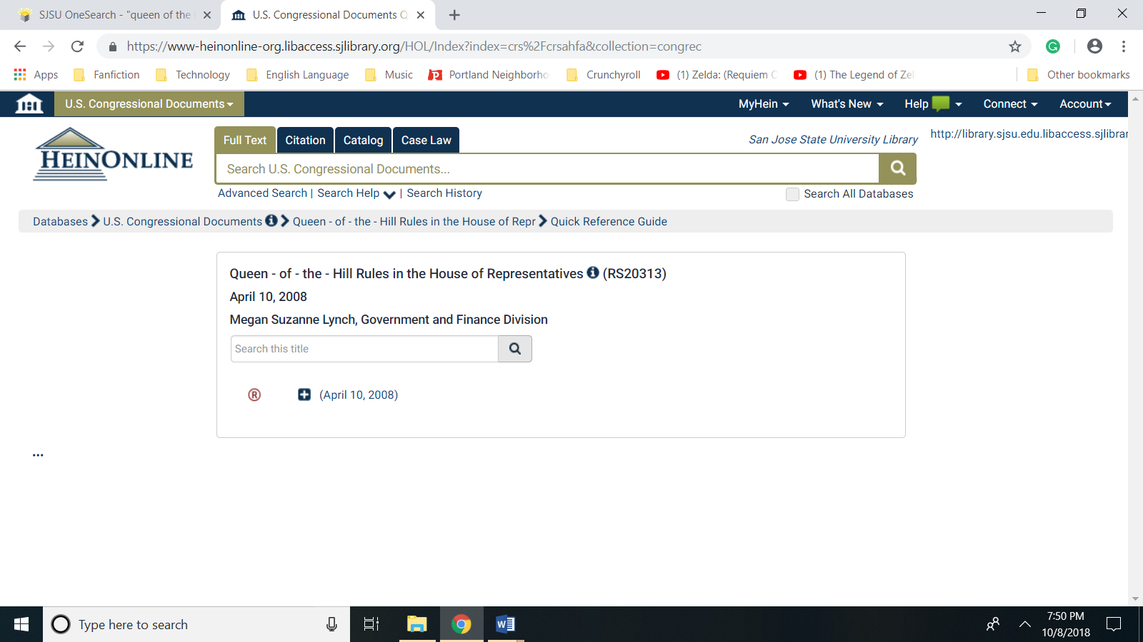

**#2 Dictionaries**

(a) Terms such as "paleo-oncology" or "bombogenesis"  are not usually found in a general dictionary.  Try using at least two specialized reference tools such as a science or technology dictionary or encyclopedia or the *Oxford English Dictionary*(OED).  In a sentence, briefly indicate what you source you used and your findings or lack thereof.  
(b) Next, check to see what kinds of scholarly sources you can find online on your term.  In a sentence or two, describe what online tools you used and what your findings were.

a) Terms such as "paleo-oncology" or "bombogenesis" are not usually found in a general dictionary. Try using at least two specialized reference tools such as a science or technology dictionary or encyclopedia or the Oxford English Dictionary (OED). In a sentence, briefly indicate what you source you used and your findings or lack thereof.

Finding definitions of bombogenesis from specialized reference tools was rather difficult, but a search for the definition of bombogenesis through the Bing search engine revealed a synonym “explosive cyclogenesis.” as shown below.

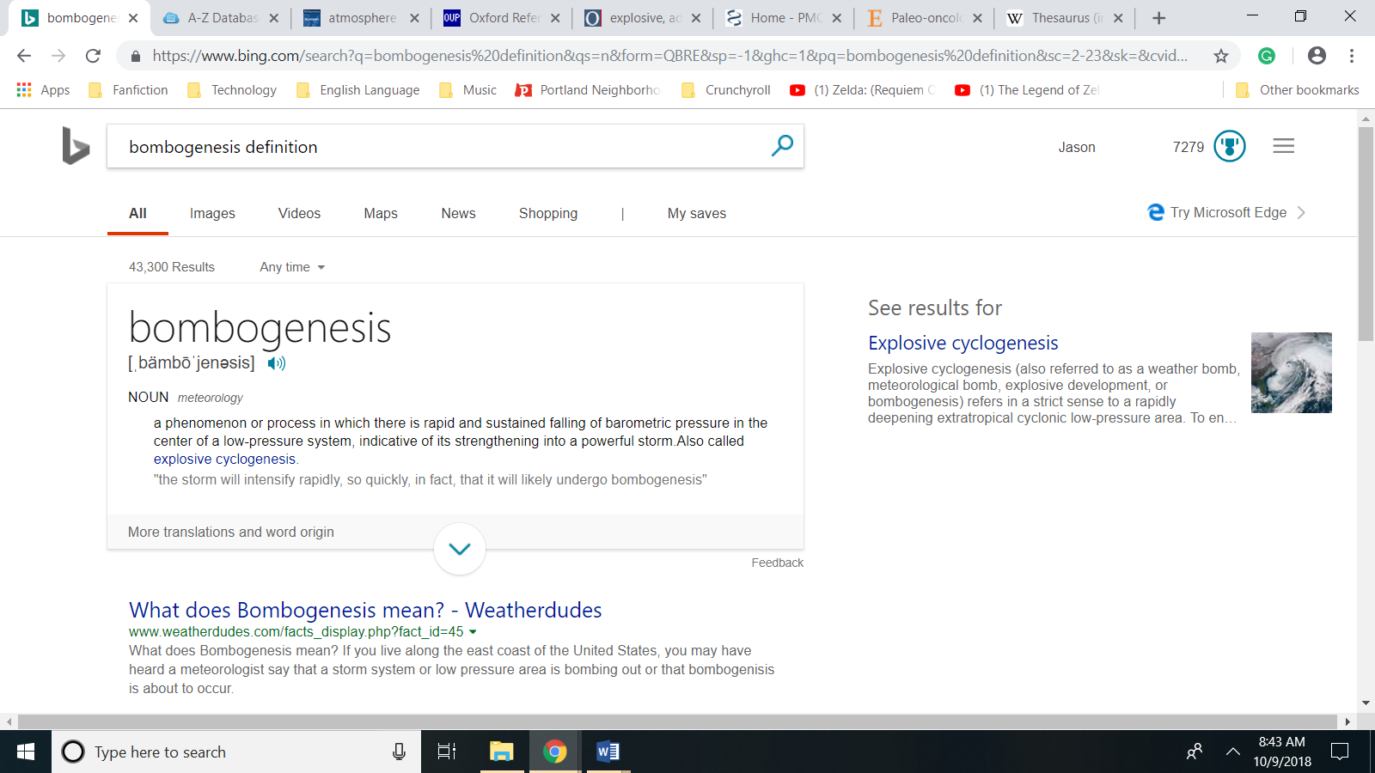

I was able to locate two sources for the definition of explosive cyclogenesis. The first was from the Oxford English Dictionary and the second was from the Academic Encyclopedia of Bratannica’s article on “Atmosphere.” Screenshots of both resources are shown on the next page.

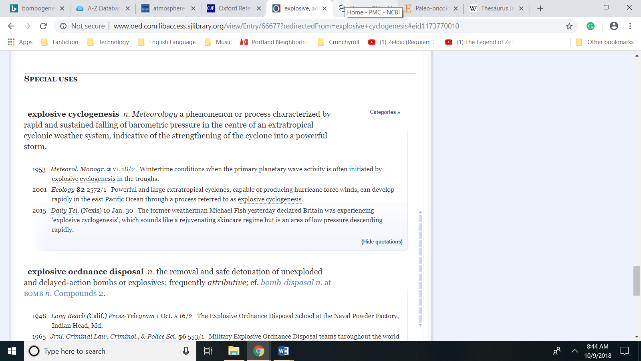

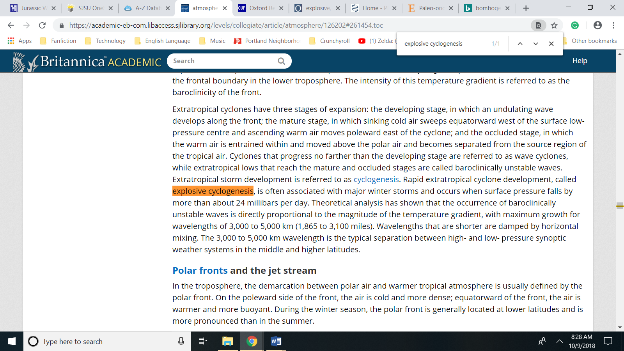

(b) Next, check to see what kinds of scholarly sources you can find online on your term. In a sentence or two, describe what online tools you used and what your findings were.

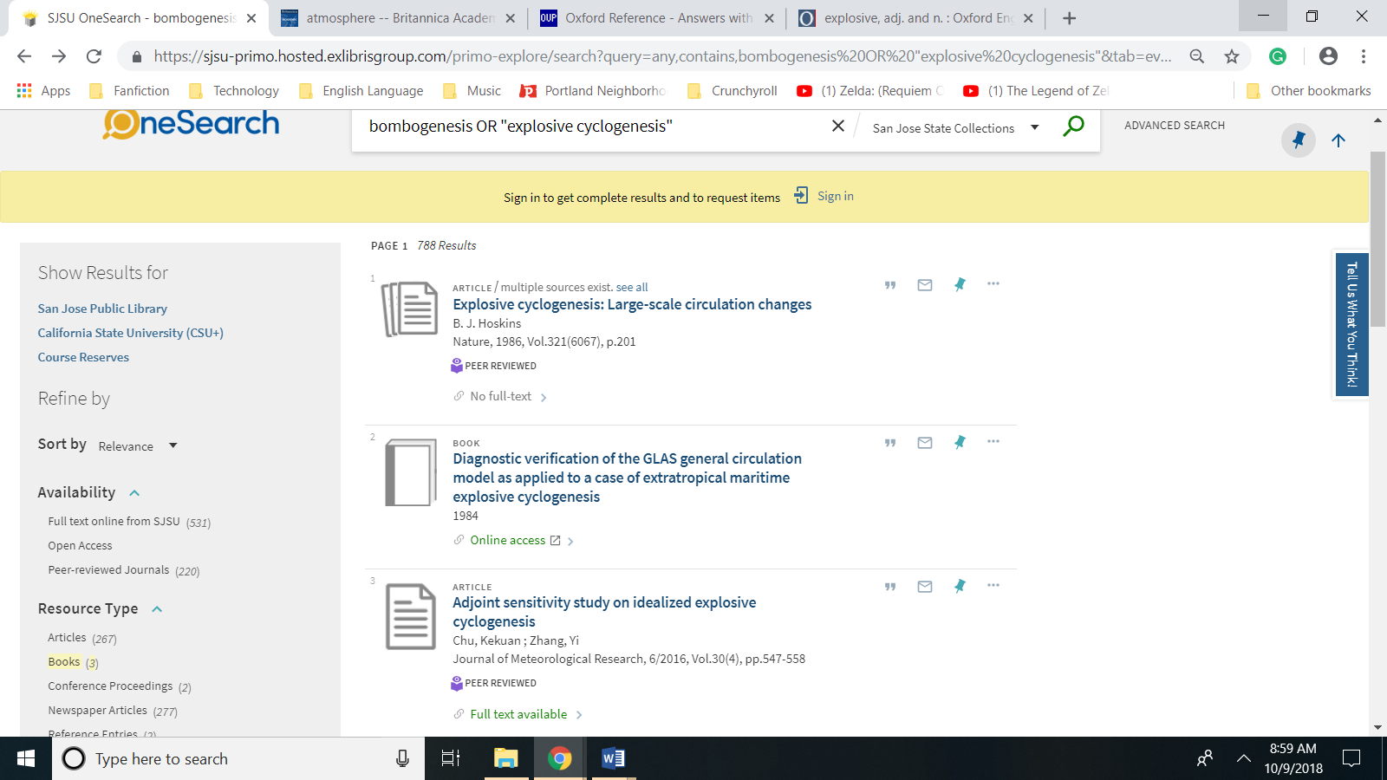

To locate scholarly sources, I went to SJSU’s Martin Luther King Library’s OneSearch to get an overview of either bombogenesis OR “explosive cyclogenesis.” The results of my query included out of 778 results three books and 531 resources—comprising mostly of articles—where the full text was immediately available. Out of the 778 results 220 of these results came from peer reviewed journals.

**3# Finding Different Types of Sources**

Another of my pet peeves is when a student is just directed to a database of articles rather than helping that person use a variety of tools to really research the topic.   
(a) Find the professional definition used by the mental health profession for autism using the **DSM 5** (*Diagnostic and Statistical Manual of Mental Disorders* -- 5th ed.). Provide a screenshot of the definition.  
(b) Provide a screenshot of your search results on autism in PsycINFO using the following criteria:  
      - Search for autism using the Subject Heading field code  
      - Age group – Childhood (birth – 12 yrs.)  
      - Methodology – Clinical trial  
      - Peer reviewed  
      - Population – Human (This is used to eliminate any possible rat studies.)  
      - Publication date – Last 12 months  
(c) Provide a screenshot of your search results in PsycEXTRA. Identify the types of resources located using PsycEXTRA.   
(d) Provide a screenshot of video search results on the topic of autism in OneSearch.  
(e) Provide a screenshot of the dissertation search results on autism completed in the last year in ProQuest Dissertations and Theses.

(a) Find the professional definition used by the mental health profession for autism using the DSM 5 (Diagnostic and Statistical Manual of Mental Disorders -- 5th ed.). Provide a screenshot of the definition.

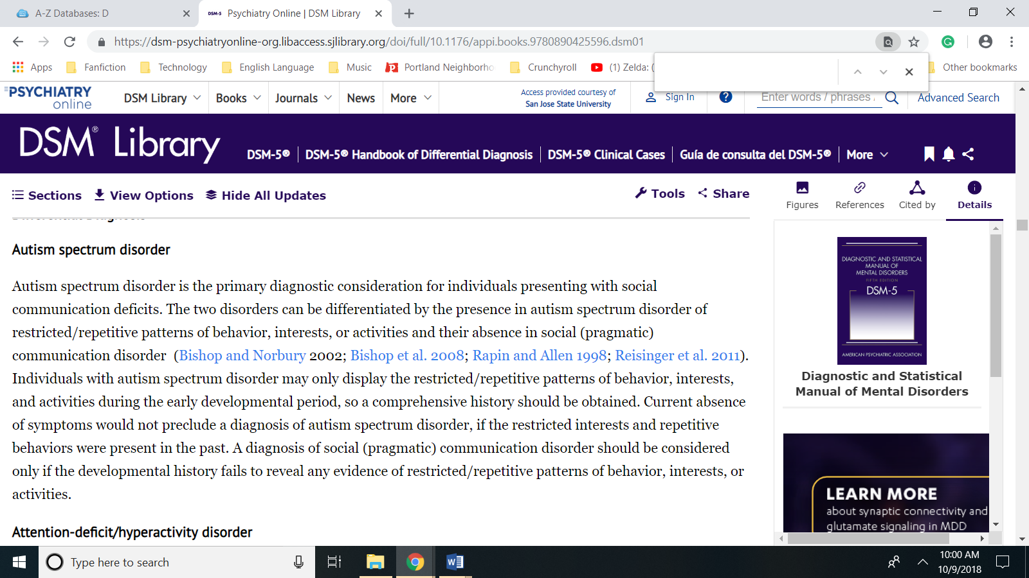

(b) Provide a screenshot of your search results on autism in PsycINFO using the following criteria:

- Search for autism using the Subject Heading field code

- Age group – Childhood (birth – 12 yrs.)

- Methodology – Clinical trial

- Peer reviewed

- Population – Human (This is used to eliminate any possible rat studies.)

- Publication date – Last 12 months

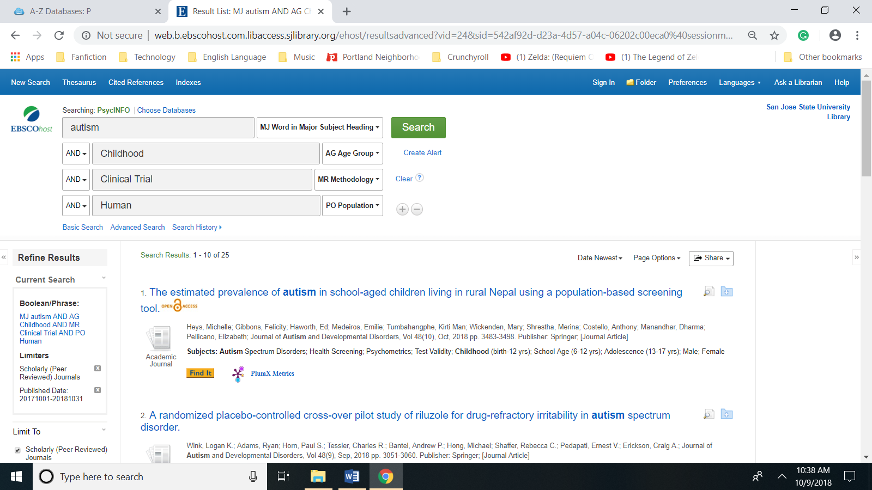

(c) Provide a screenshot of your search results in PsycEXTRA. Identify the types of resources located using PsycEXTRA.

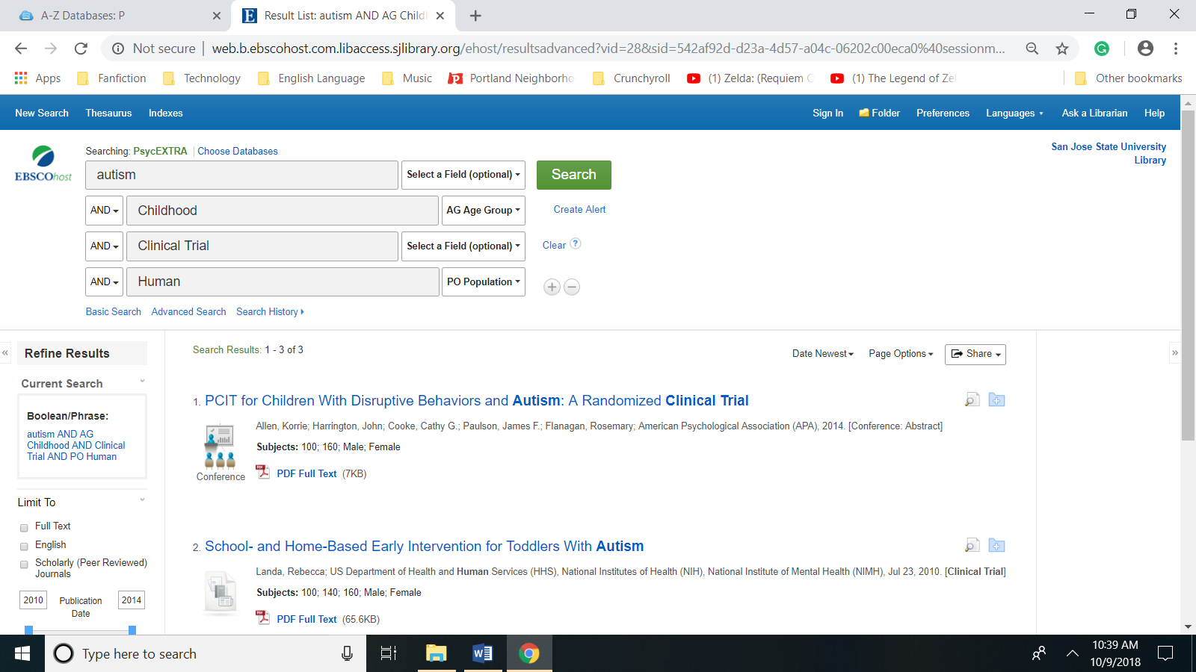

When using the EBSCO interface to switch databases from PsycINFO to PsycEXTRA the results were reduced to three clinical trials.

(d) Provide a screenshot of video search results on the topic of autism in OneSearch.

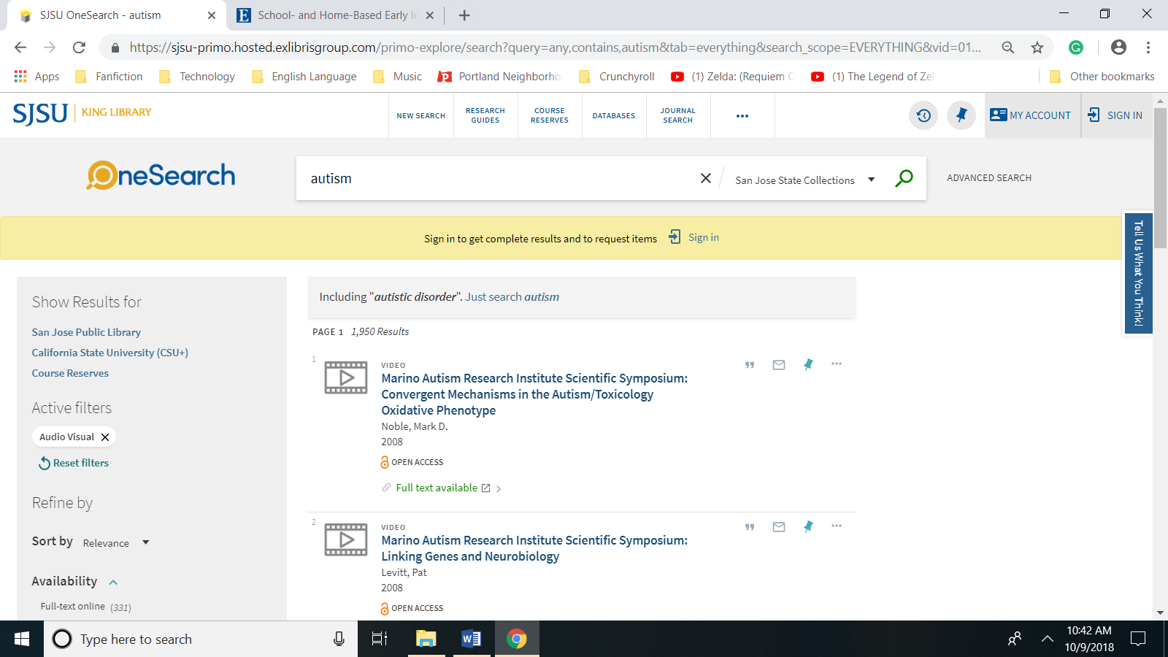

(e) Provide a screenshot of the dissertation search results on autism completed in the last year in ProQuest Dissertations and Theses.

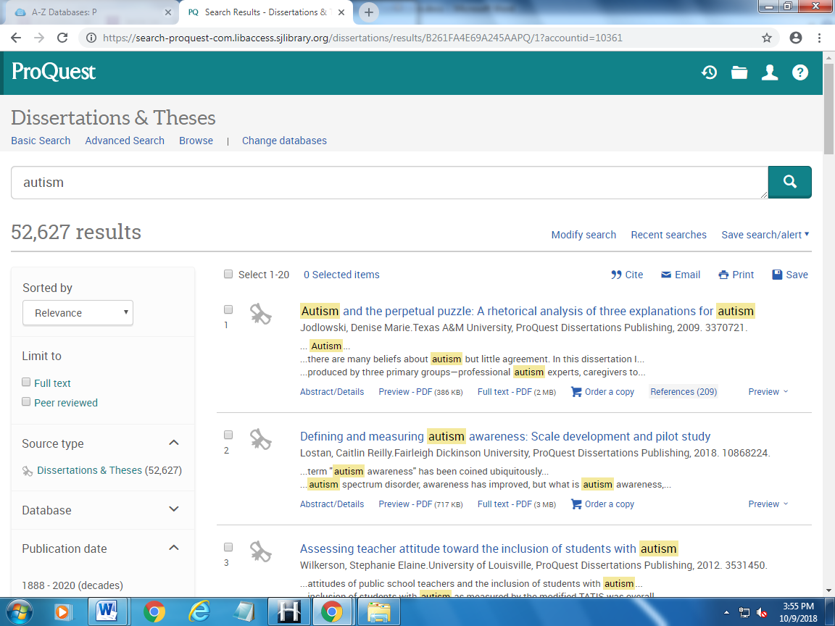

**#4 & 5 Online Encyclopedias**

After reading about selecting encyclopedias in one of the readings, I want you to be able to physically access the encyclopedias you are going to evaluate online or in print so take a look at the various online encyclopedias available through the King Library. For example, if you go to the A-Z list of databases, you will find a number of encyclopedias listed in the **E** section! You can also try browsing databases like Gale Ready Reference Shelf and/or Gale Virtual Reference Library. You will want to select three encyclopedias that you will be evaluating, and at least one encyclopedia should have a multimedia component.   
(a) Identify the type of library setting where your three encyclopedias might be added.   
(b) Choose five evaluation criteria such as coverage, searchability, age appropriateness, special features, etc. Rather than writing out an explanation of your criteria, it may be easier to use a quick table to summarize your findings if you prefer.

(a) Identify the type of library setting where your three encyclopedias might be added.

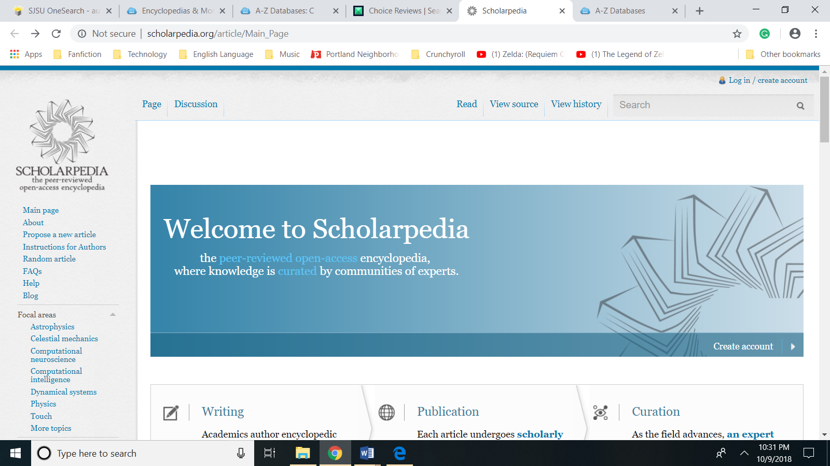

|  |  |  |  |
| --- | --- | --- | --- |
| Encyclopedia  Title | Scholarpedia | Encyclopedia of Britannica | Music Online: The Garland Encyclopedia of World Music |
| Description | A peer-reviewed open-access encyclopedia written by scholars from around the world and focusing on Scholarpedia covers computational neuroscience, computational intelligence, dynamical systems, astrophysics and physics. | Full text of the 32-volume Encyclopædia Britannica (additional articles and images not available in the print set); Merriam Webster's Dictionary; over 130,000 links to web sites selected, rated, and reviewed by Britannica editors. Other resources include country comparisons and data analysis; history timeline; brief biographies; as well as articles from the New York Times and the BBC. | Resource for music research of world's peoples that contains an overview of the region, a survey of its musical heritage, traditions and themes; and a description of specific musical genres, practices, and performances. Articles include detailed photographs that show musicians, musical instrument, and the cultural context of dances, rituals, and ceremonies. Other images include drawings, maps, and musical examples for further study. |
| Applications | Scholarpedia is a useful resource for students, researching and practitioners in the fields of neuroscience, physics, and astrophysics. With the exception of its articles being too advanced for certain age groups, the open access nature of Scholarpedia makes it difficult to imagine why any library would avoid linking their website to this resource. | As a general encyclopedia it is applicable to all types of libraries as a useful starting point for research. | High School and Junior High Libraries with emphasis on music or performing arts as well as institutions of higher learning that support studies in music or more broadly the social sciences. |

(b) Choose five evaluation criteria such as coverage, searchability, age appropriateness, special features, etc. Rather than writing out an explanation of your criteria, it may be easier to use a quick table to summarize your findings if you prefer.

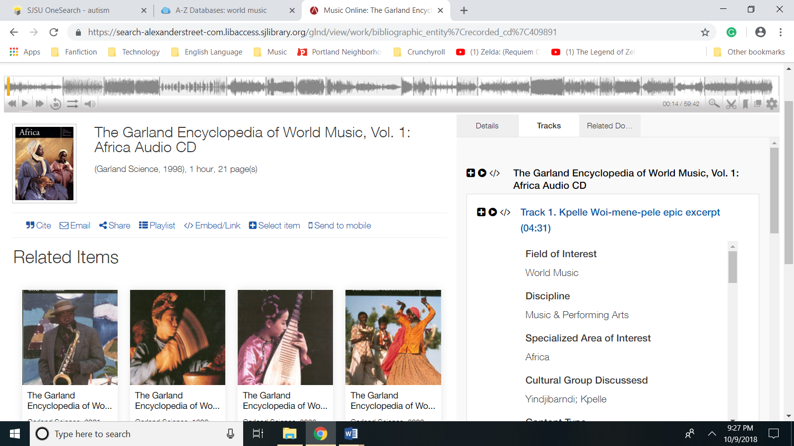

|  |  |  |  |
| --- | --- | --- | --- |
| Encyclopedia Title | Scholarpedia | Encyclopaedia Britannica Online, Academic Edition | Music Online: The Garland Encyclopedia of World Music |
| Description | As a peer-reviewed encyclopedia written by scholars from around the world and focusing on Scholarpedia covers computational neuroscience, computational intelligence, dynamical systems, astrophysics and physics. | Full text of the 32-volume Encyclopedia Britannica (additional articles and images not available in the print set); Merriam Webster's Dictionary; over 130,000 links to web sites selected, rated, and reviewed by Britannica editors. Other resources include country comparisons and data analysis; history timeline; brief biographies; as well as articles from the New York Times and the BBC. This resource features a selection of video content.. | Resource for music research of world's peoples that contains an overview of the region, a survey of its musical heritage, traditions and themes; and a description of specific musical genres, practices, and performances. Articles include detailed photographs that show musicians, musical instrument, and the cultural context of dances, rituals, and ceremonies. Other images include drawings, maps, and musical examples for further study. |
| Reliability (Accuracy, Authority) | As a peer-reviewed resource limited to a narrow range of subject matter. | The Encyclopedia Britannica’s traditional content is accurate and credible, but its links to current new articles introduces a source of potential inaccuracy. | Because the focus of this resource is musical heritage and themes, currency is less of an issue. |
| Suitability (Age Appropriateness) | A cursory survey of featured articles revealed that knowledge of medical or scientific jargon is not required to assimilate the knowledge contained within such articles, therefore Scholarpedia is suitable for all patrons with a high school education or above. | Articles are assessible to persons with adequate proficiency in the English Language | The articles are age appropriate and are assessible to individuals who are proficient in English. |
| Usability (Indexing, Style, User-Friendliness) | By featuring an interface that is similar to Wikipedia, Scholarpedia is assessible to a multitude of users. Articles may also feature multimedia components such as animated graphics that improve the usability of Scholarpedia. | The search functionality includes a “fuzzy" search option that identifies terms in with similar spellings to improve the search performance of the Encyclopedia of Britannica. Great pains have taken to make this resource compatible with the standards in today’s digital environment including sharing of content through email and allowing for exports via Excel. | The interface is adequate allowing for the full text searching of the 10 volume set using keyword search and provides guidance in searching its articles. The inclusion of sound recordings enhances the content of this resources |
| Cost | As an open access resource, this resource is free for all patrons to use. | Annual subscription is $0.60 per weighted user, with a minimum price of $390.00 | Annual academic subscription range: $600 to $1,000 |

**#6 Amazon.com**

In the past, librarians used Books in Print as the go-to resource for information about books, book publishers, series, new releases, etc. However, in the 21st century, Amazon.com has become an indispensable tool for many reference librarians. Talk to a reference librarian about ways he or she utilize Amazon.com and what other sources they use for verifying authoritative book information.  Summarize your findings in a couple of sentences.

The reference desk at the Central Library of the Fresno County Public Library uses Amazon for the publication date of books and movies and has a guide to locating obscure print materials when traditional searching in the catalog fails. Occasionally, they will consult novel list during the course of reader advisory before making a recommendation. The staff person (not a librarian) was unaware of Books in Print.