Jason Sue

INFO 210-11

Dr. Johanna Tunon

Fall 2018

**Mini Activity 5: Search Strategies**

**Searching the EBSCO Database**

Use a multidisciplinary database such as OneSearch or Academic Search Complete on the topic of menu labeling and whether it makes a difference in eating habits. Start by using the search terms menu AND labeling AND eating habits.  
(a) Identify the database used.  
(b) Identify any equivalent terms that could/should be used.  
(c) What subject headings were recommended?  
(d) What methods would you recommend for filtering the results to locate sources that actually address whether food labeling actually makes a difference in eating habits rather than just mentioning all three terms.

(a) Identify the database used.

Academic Search Complete

(b) Identify any equivalent terms that could /should be used?

menu: restaurant, cafeteria

labeling: packaging classifying, tagging

eating: eat, ate, diet, “eating habits,” consumption, dining, snacking

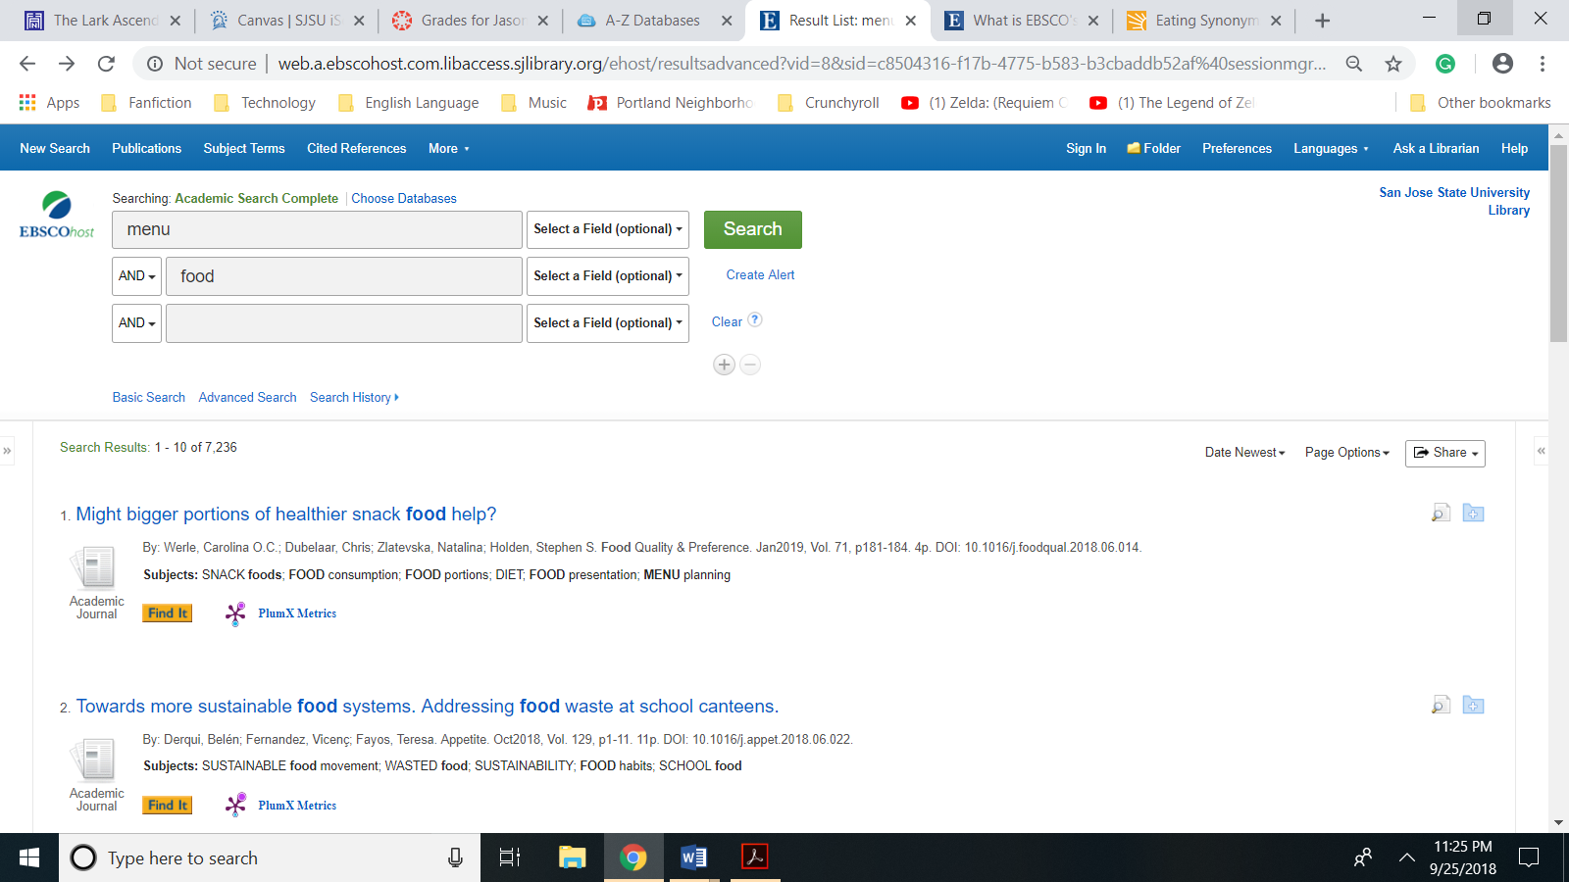

(c) What subject headings were recommended?

FOOD labeling

Packaging and Labeling Services

FOOD habits

Menu planning

Restaurant Menus

Food Portions

(d) What methods would you recommend for filtering the results to locate sources that actually address whether food labeling actually makes a difference in eating habits rather than just mentioning all three terms.

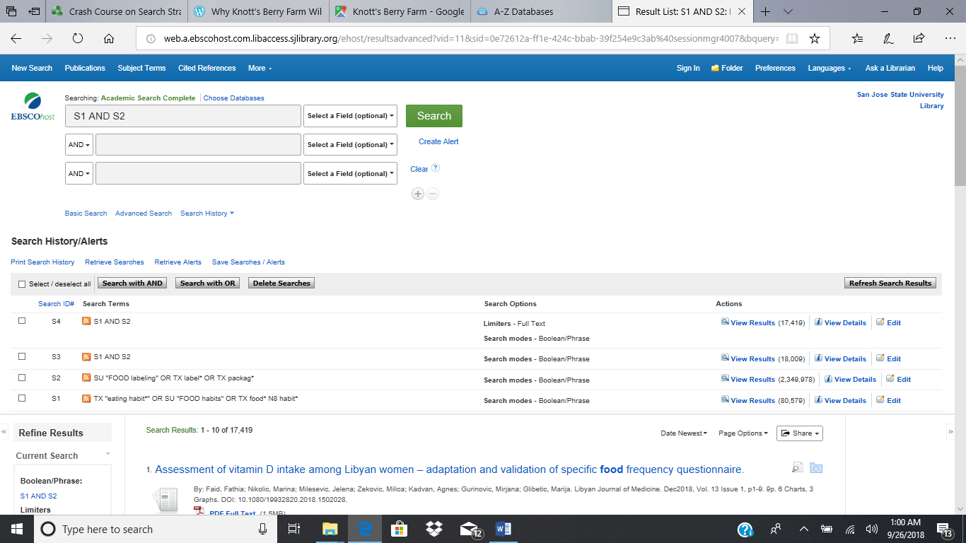

I would recommend the following query.

(TX “eating habit*” OR (SU “FOOD habits”) OR (TX (food* N8 habit*))) AND ((SU “FOOD labeling”) OR (TX packag*) OR (TX label*))

The filters result in the intersection of two domains. The first domain is all documents that have the phrase “eating habit” in all text or the Comprehensive Subject Index (CSI) subject term “FOOD habits” OR if for all text there is an instance where a document has the truncated stem “food*” being eight words near the truncated stem “habit*”. The second domain is all the documents that have the CSI subject term FOOD labeling OR have the truncated stem “package*” OR have the truncated stem “label*”

In addition, I also recommend filtering to include **Full Text** only. When all of these filters were in place, Academic Search Complete retrieved 17,419 results. Upon browsing these results, IO discovered that my query could be further refined by excluding the documents that mention pets and other animals.

**Search Terms**

Using the topic of the European storm-petrel, try searching:  
(a) OneSearch  
(b) a **reference database** such as Gale Virtual Reference Online, Oxford Reference, or Credo Reference.

Use three search terms or strategies or choose alternative terms if appropriate:

petrel* (truncation to look for the singular and plural of the term)  
Variations of spelling -- European storm-petrel or European storm petrel

(a) OneSearch (San Jose State Collections)

Strategy 1: No Boolean Operators, No Limiters, No Phrasal Searching

Query: European storm-petrel

Results: 873

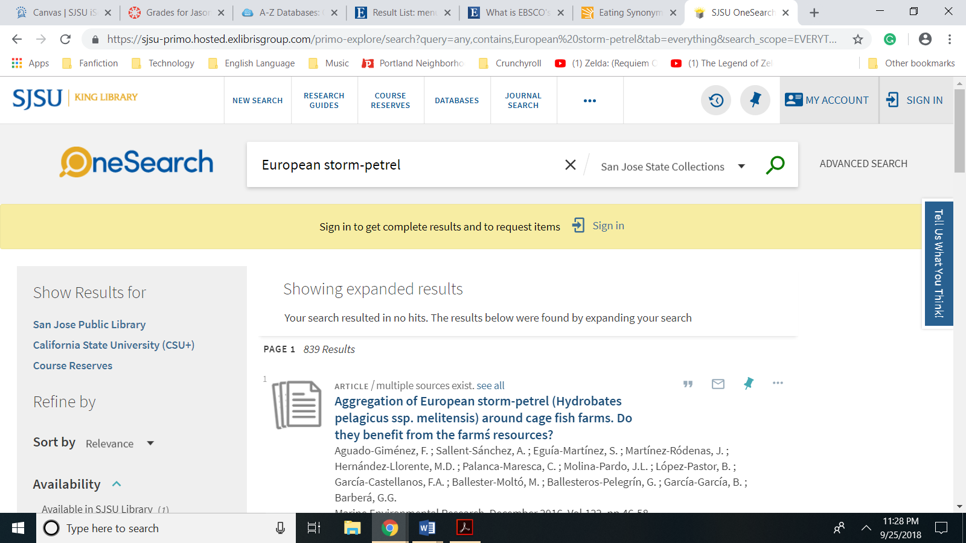

(a) OneSearch (San Jose State Collections) (continued)

Strategy 2: Phrasal Searching and Employment of the Boolean Operator OR for the hyphenated and Unhyphenated Versions of “European storm-petrel”

Query: "European storm petrel" OR "European storm-petrel"

Results: 179

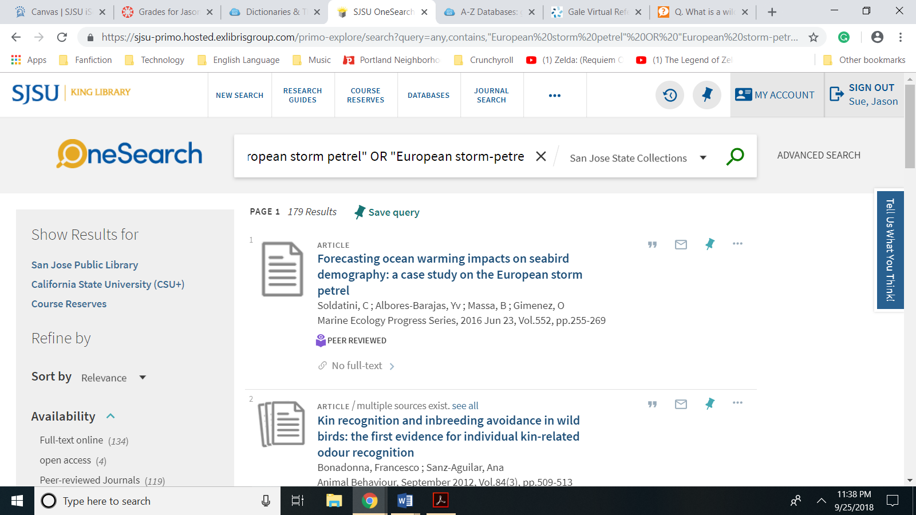

Strategy 3: Phrasal Searching and Employment of the Boolean Operator OR for the hyphenated and Unhyphenated Versions of “European storm-petrel” and Employment of the Boolean Operator AND for the Term “Hydrobates pelagicus” and the Employment of the Parenthesis to Dictate that the OR Operator Is Processed before the AND Operator

Query: ("European storm petrel" OR "European storm-petrel") AND "Hydrobates pelagicus"

Results: 123

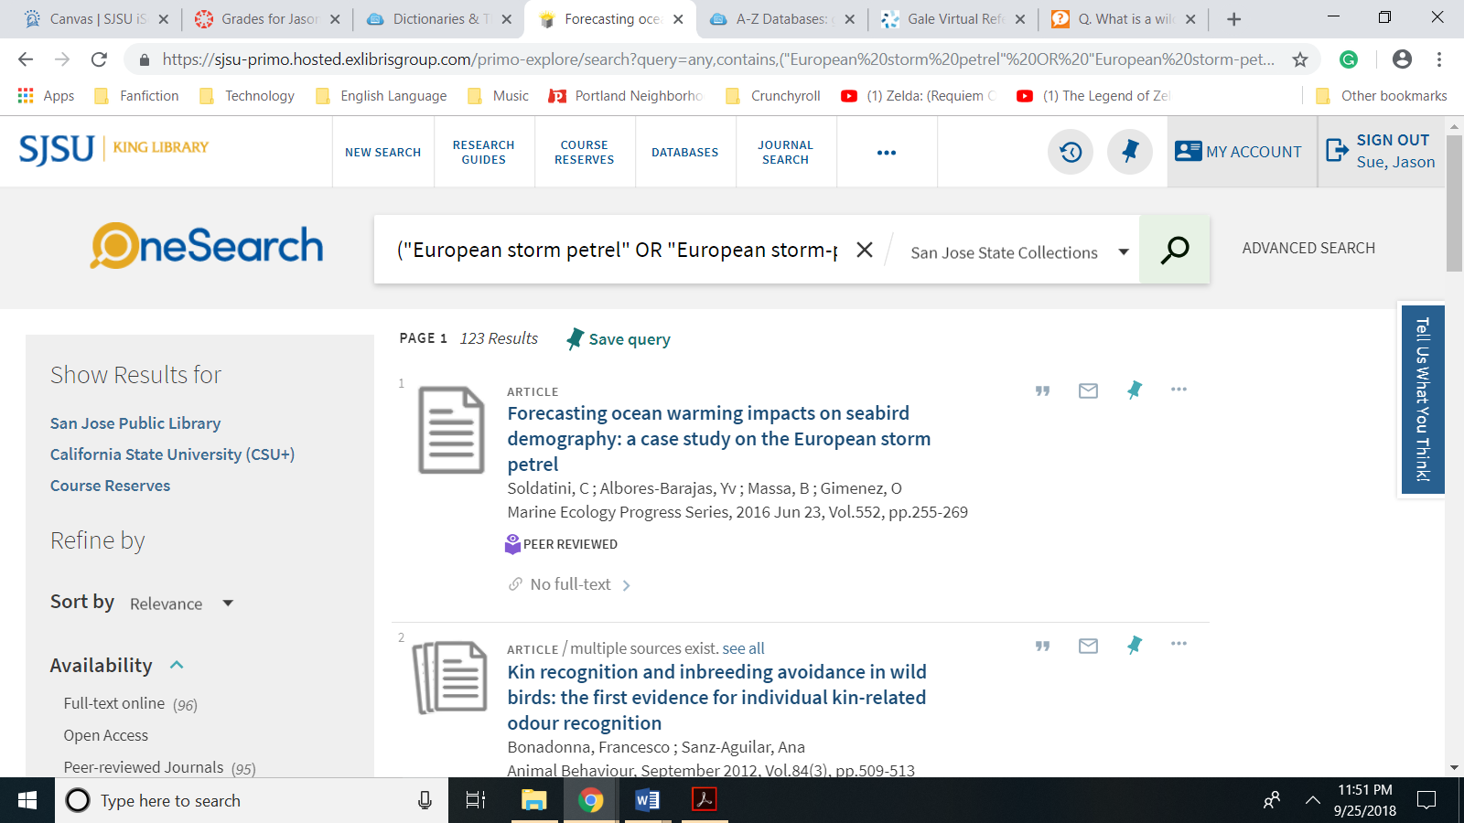

(b) Gale Virtual Reference Online

Strategy 1: No Boolean Operators, No Limiters, No Phrasal Searching; Keyword Search

Query: European storm-petrel

Results: 297,820

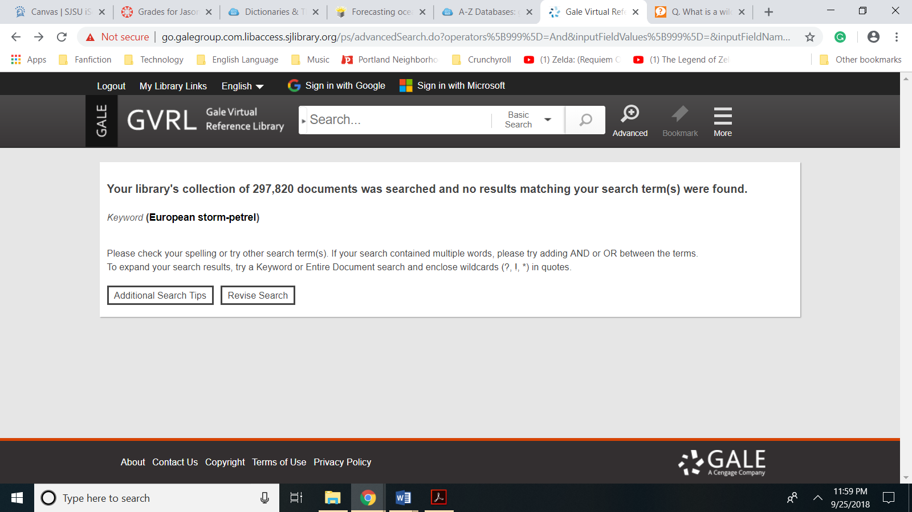

Strategy 2: Phrasal Searching and the Employment of a Wild Card to Capture both the Hyphenated and Unhyphenated form of “European storm-petrel”; Basic Search

Query: "European storm?petrel"

Results: 1 i.e. The article “Storm-Petrels” from the Animal Life Encyclopedia

John Warham . Ed. Michael Hutchins, Arthur V. Evans, Jerome A. Jackson, Devra G. Kleiman, James B. Murphy, Dennis A. Thoney, et al.  Vol. 8: *Birds I*.  2nd ed.  Detroit: Gale, 2004.

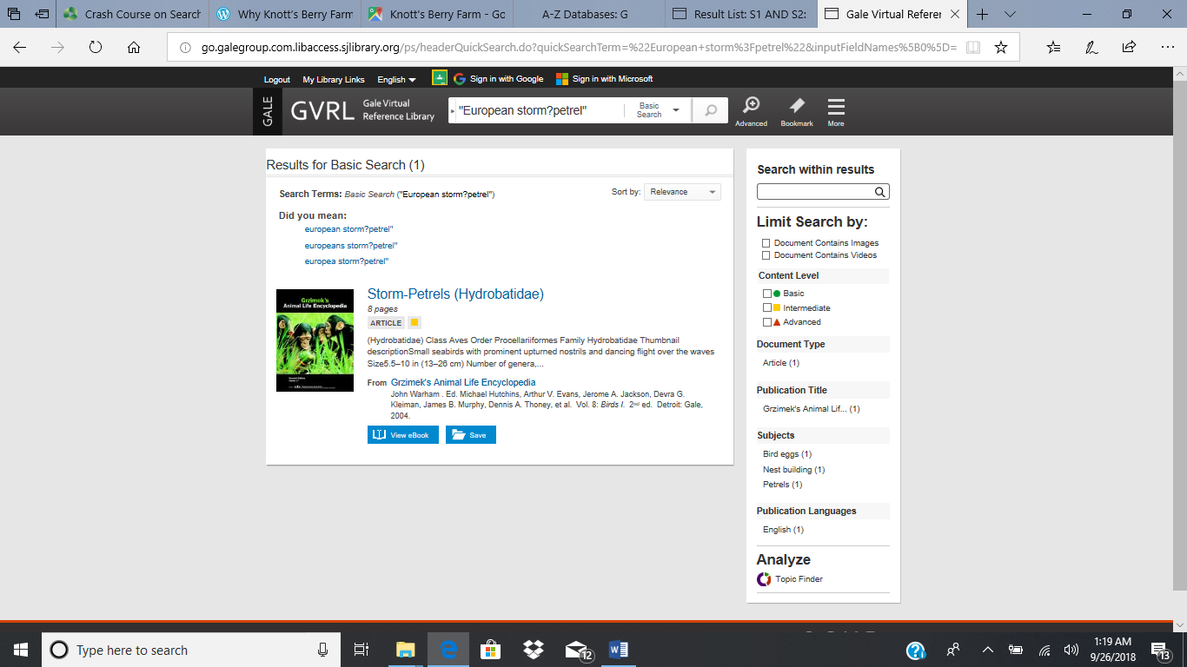

(b) Gale Virtual Reference Online (continued)

Strategy 3: Phrasal Searching and the Employment of a Wild Card to Retrieve records that include both the Hyphenated and Unhyphenated form “European storm-petrel*” OR the scientific name: “Hydrobates pelagicus”; Basic Search

Query: "European Storm?petrels" OR "Hydrobates pelagicus"

Results: 2

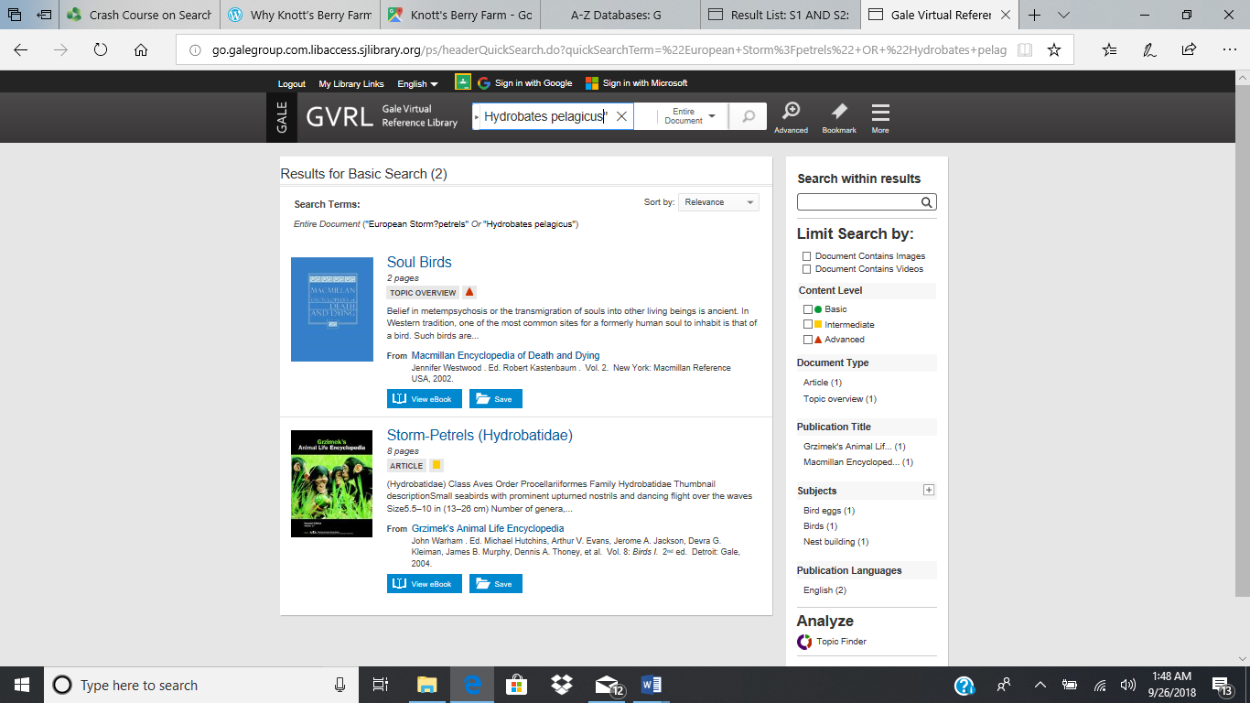

(c) Identify two filters that are useful to use in one of your databases for your search strategy.

Because nearly every instance of the “European storm-petrels” is used in a specific order, the filter that had the greatest impact on results was using phrasal searching to retrieve any records that specifically included the term “European storm-petrels” as opposed to searching for European AND storm-petrels. When using OneSearch (San Jose State Collections), employing the AND operator to filter out results that didn’t include the term “Hydrobates pelagicus” also narrowed the number of results retrieved.

(d) Summarize your findings on the terms and strategies that worked best in each of your two sources.

OneSearch (San Jose State Collections) initially returned 879 results and required me to narrow down the results first by employing the phrasal searching and then by using the AND Boolean operator to return results that only include the species scientific name. For the Gale Reference Center, which is limited to only reference materials, phrasal searching quickly narrowed down to one resource retrieved. On my third strategy I tried to broaden the search by using the OR operator, but with limited success. This broader search only retrieved one additional resource from the Macmillan Encyclopedia of Death and Dying. This article is titled “Soul Birds” and refers to the reincarnation of humans as birds.

**Search Terms** (continued)

Using the topic of the European storm-petrel, now try searching:

(a) a**subject database** such as ScienceDirect or BioOne, and   
(b) a **multidisciplinary database** such as Academic Search Premier or ProQuest Central .

Choose three of these search terms or other terms/strategies if appropriate:

seabird  
petrel*  (truncation to look for the singular and plural of the term)  
Variations of spelling -- European storm-petrel or European storm petrel  
Phrase searching -- "European storm-petrel" or "European storm petrel"  
Scientific term -- Hydrobates pelagicus or "Hydrobates pelagicus"

(c) Identify two useful filters that can be used to narrow your results in one of the databases you selected.  
(d) Summarize your findings on the terms and strategies

(a) Subject Database: ScienceDirect

Strategy 1: Phrasal Searching

Query: "European storm-petrel"

Results: 53

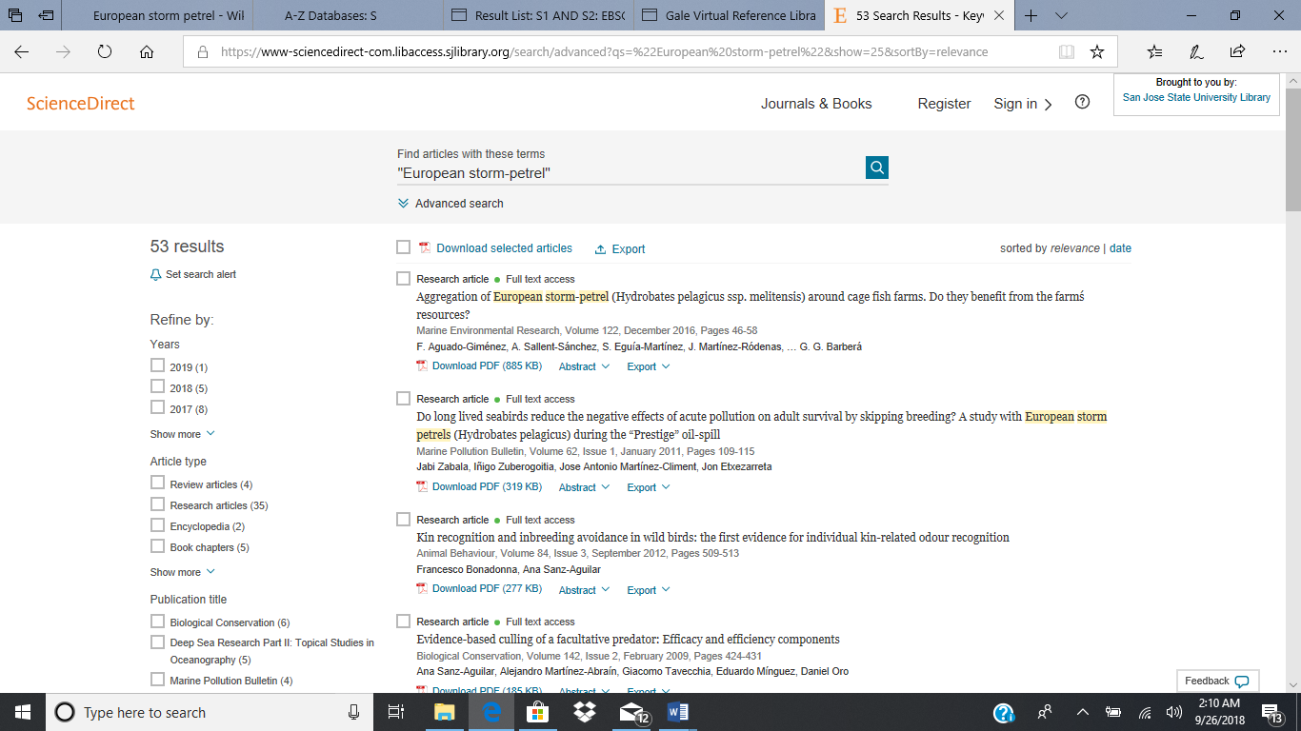

(a) Subject Database: ScienceDirect (continued)

Strategy 2: Phrasal Searching and the Employment of the AND Operator

Query: "European storm-petrel" AND "Hydrobates pelagicus"

Results: 41

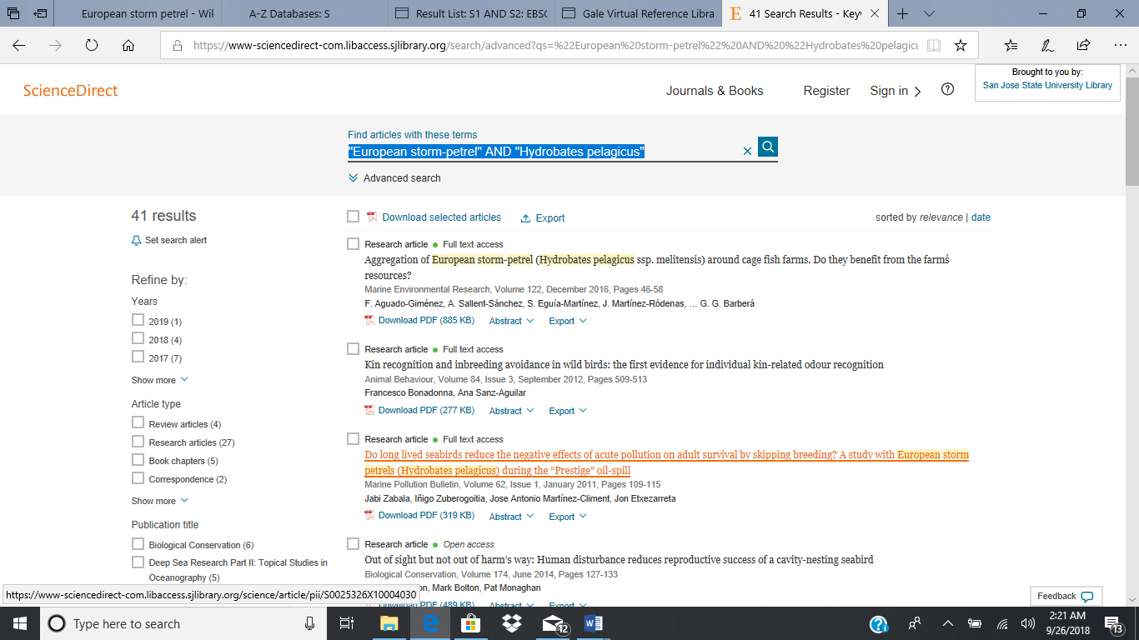

Strategy 3: Phrasal Searching and the Employment of the AND Operator

Query: "European storm-petrel" AND "Hydrobates pelagicus"

Filter: Publication Type—Research Articles

Results: 21

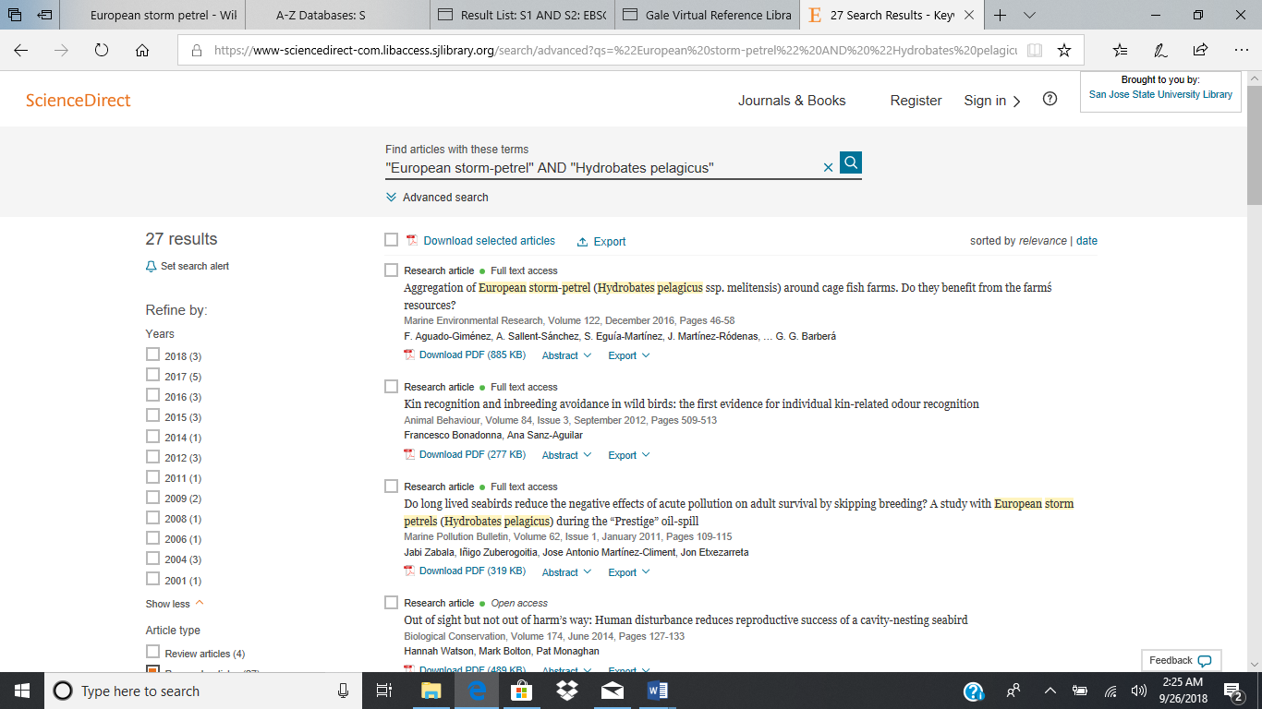

(b) Multidisciplinary Database: Academic Search Complete

Strategy 1: Phrasal Searching; All Text

Query: "European storm-petrel"

Results: 54

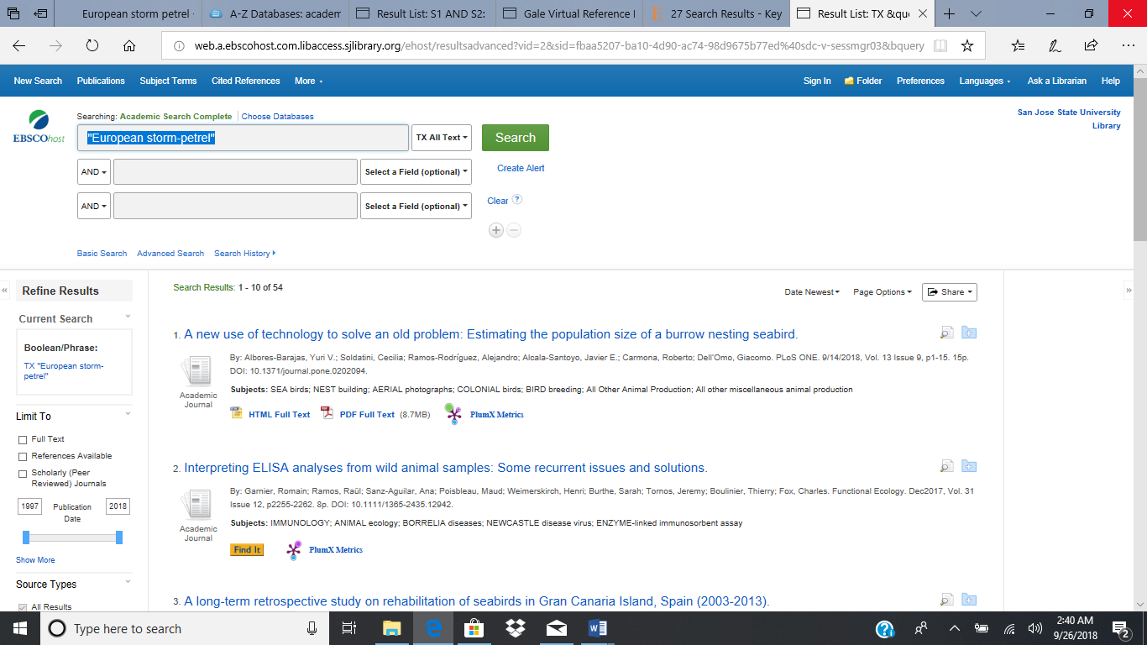

Strategy 2: Phrasal Searching; All Text

Query: "European storm-petrel"

Filter: Full Text Available

Results: 41

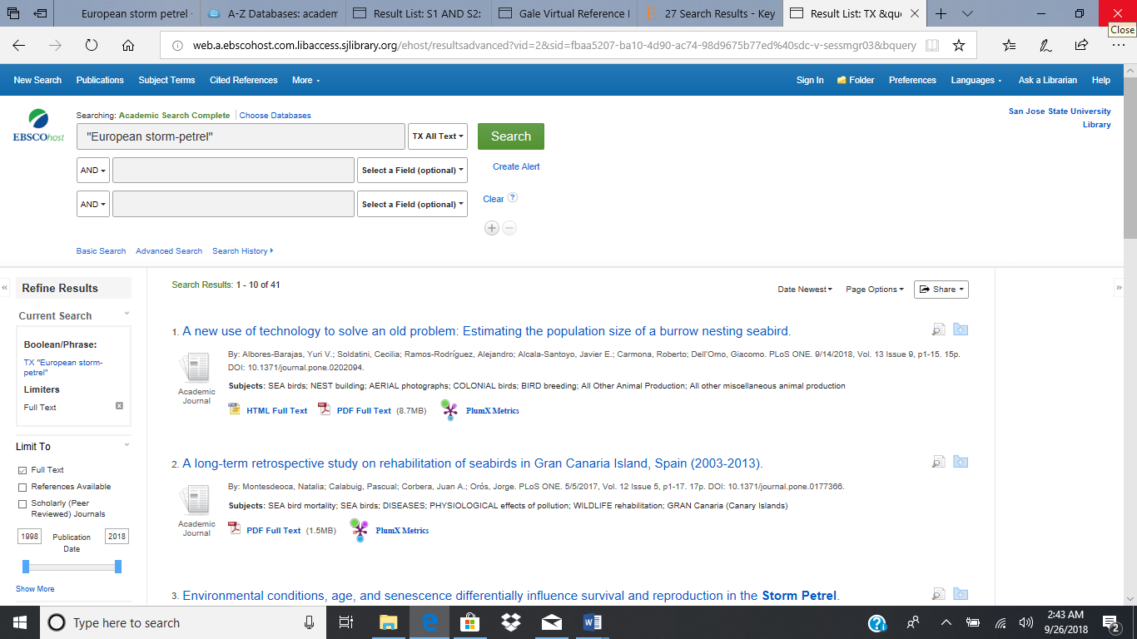

(b) Multidisciplinary Database: Academic Search Complete (continued)

Strategy 3: Phrasal Searching; Restricted to Title

Query: "European storm-petrel"

Filter: Full Text Available

Results: 3

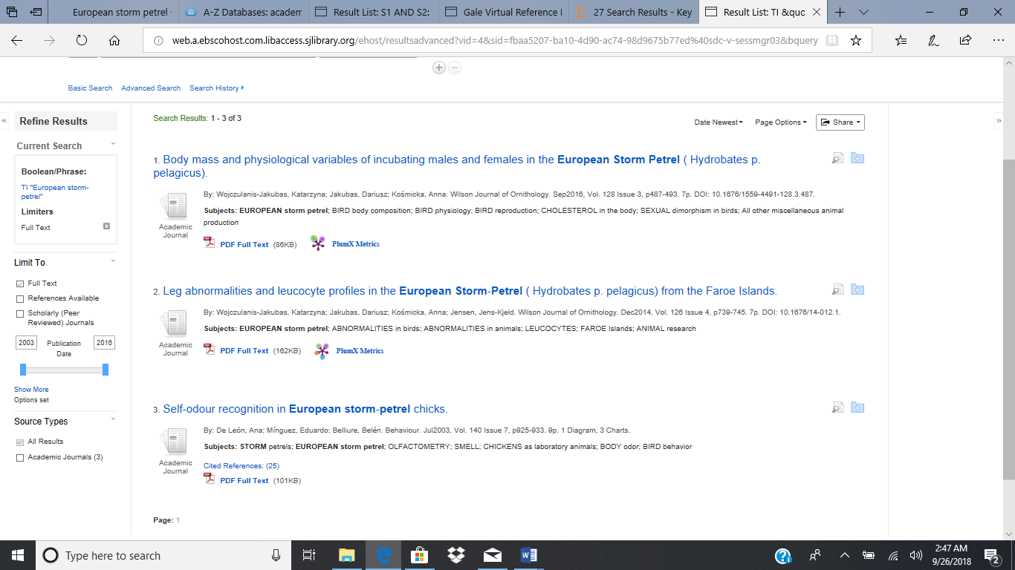

(c) Identify two useful filters that can be used to narrow your results in one of the databases you selected.

The filter that I find to be the most useful from EBSCO’s interface it the Full Text filter which limits retrievals to documents I can immediately use. When researching for project from a time management perspective, research articles are much easier to accommodate than larger works of literature. In this respect, the ScienceDirect database publication filters are most useful.

(d) Summarize your findings on the terms and strategies that worked best in each of your two sources.

I immediately went to the advanced search menu for the subject database ScienceDirect to help grasp the types of filters that were available to me through the ScienceDirect interface. Using phrasal searching for the term “European storm-petrel” as my first strategy, I discovered that the search retrieved articles that used either the hyphenated or unhyphenated forms. In my second strategy, I attempted to filter out results that did not include the scientific name “Hydrobates pelagicus” using the AND Boolean operator. This decreased the number of results from 53 to 41. I further decreased the number of retrievals by restricting result by publication type by applying a filter that only allowed for the retrieval of research articles limiting. The application of this filter nearly halved the number of results from 41 retrievals to 21 results.

(d) Summarize your findings on the terms and strategies that worked best in each of your two sources. (continued)

For the Academic Search Complete database, my initial phrasal search used the term “European storm-petrel” and retrieved 54 results. Included in these results were retrievals of both the hyphenated and unhyphenated forms of the search term. My second search strategy added the full text available filter, which reduced the number of results from 54 to 41 retrievals. In an attempt to limit the results to works who focused on the European Storm-petrel, I limited retrieval to articles who contained the term “European storm-petrel” in the title. Unfortunately, this produced a domain containing only three results and would far too narrow for the purposes of a research project.

**Search Engines**

Try searching Google and another search engine such as Bing, Quora, Yahoo!, Ask.com, or DuckDuckGo for a search topic of your choice.  
(a) Identify the search engines you selected. Describe your search topic and what you located.  
(b) Describe which search engine you preferred and why.  
(c) Go to the list of King Library databases and select Google Scholar.

- Set your library preferences on the Google Scholar homepage by going to Scholar Preferences.   
- At Library Links, locate San Jose State University.   
- Add those links, and then save the preferences.  
- This should allow you to link to the full text of articles available through the King Library.

(d) Report your search in Google Scholar and discuss how your search results compared to the other two search engines.

(a) Identify the search engines selected. Describe your search topic and what you located.

I selection as a way familiarize myself with this reference tool. In the past, search engines result have directed me to the Quora platform. Therefore, the two search engines I am using are Google and Quora. For my topic, I have selected the topic of “Anne Frank” for the purposes of this exercise. The results returned from the Google Search are relevant and—with the exception of Wikipedia article—authoritative and highly credible, as shown in the following screenshot. Some of sources from the first page of results included the Anne Frank House, Biography.com, and The Washington Post.

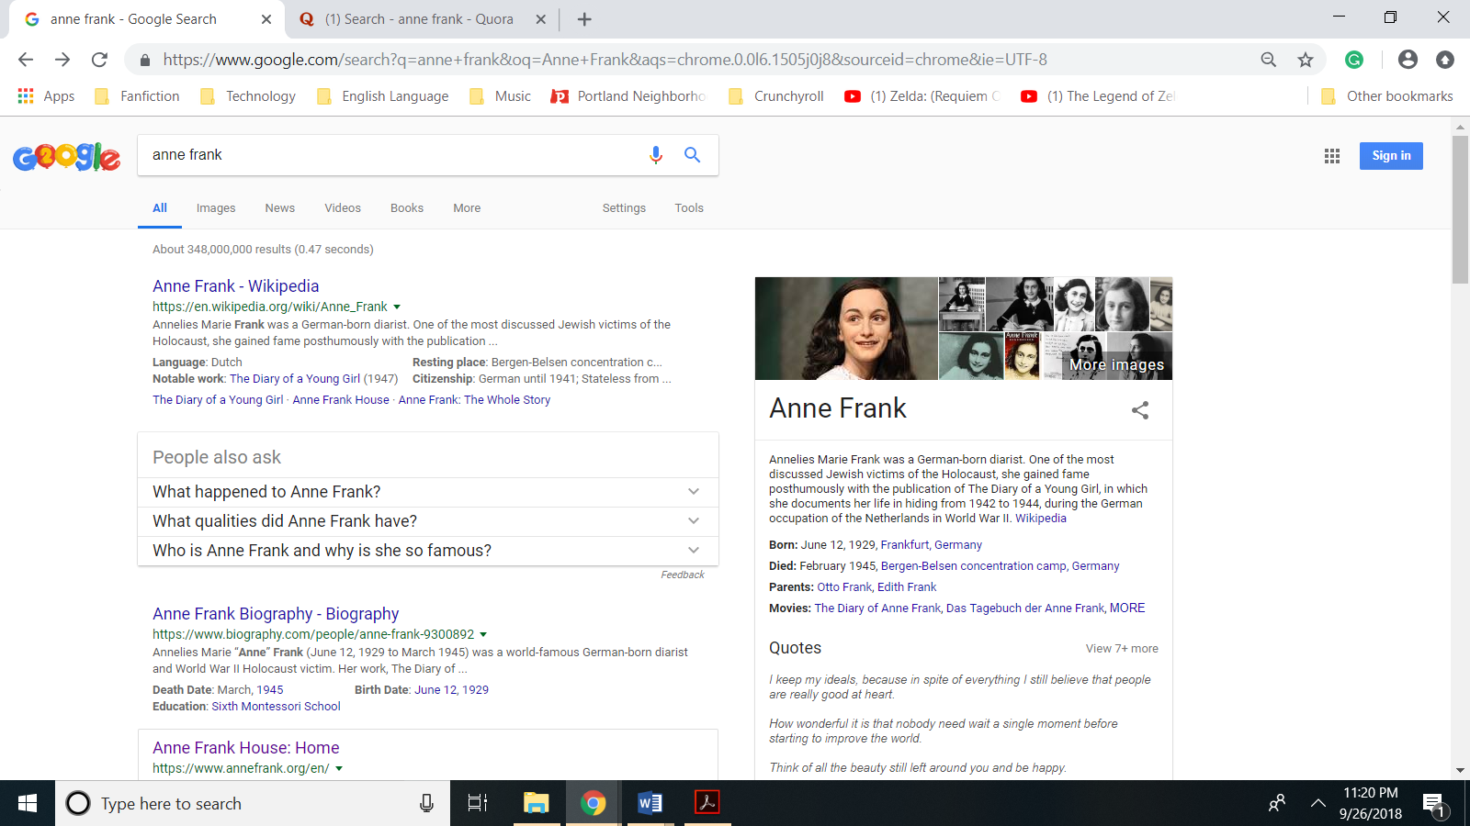

Quora on the other hand retrieved a list of queries. including the question “Why didn’t Anne Frank write her diary in German?” and the question “Was Anne Frank a real person?” Reading through some of these discussion threads found within the Anne Frank information community is quite interesting on the give and take particularly on controversial positions.

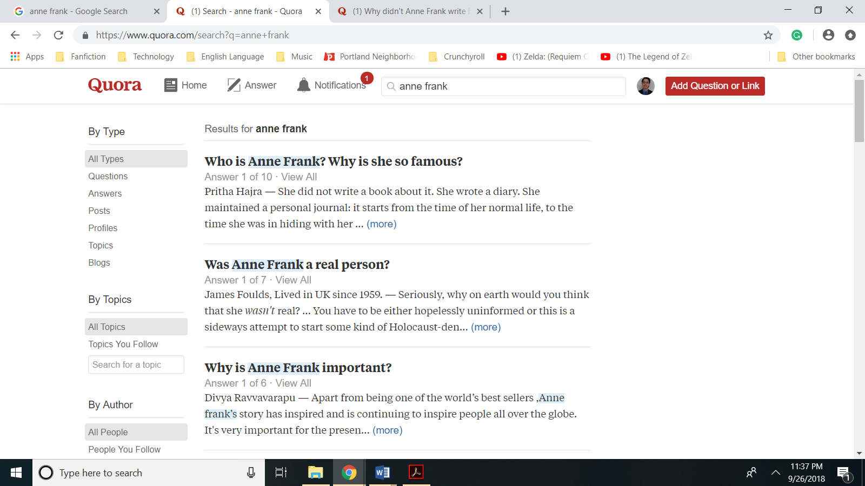

(b) Describe which search engine you preferred and why.

I prefer the Google search engine, as it provides both relevant and credible avenues of information. In spite of this, this assignment has encouraged me to include Quora in my future research endeavors. While information from Quora’s community produced content requires verification from a more authoritative source, Quora provides exposure to a varying viewpoints and retrieved query’s can open up new avenues of research that may not have been previously considered.

(c) Go to the list of King Library databases and select Google Scholar.

- Set your library preferences on the Google Scholar homepage by going to Scholar Preferences.

- At Library Links, locate San Jose State University.

- Add those links, and then save the preferences.

- This should allow you to link to the full text of articles available through the King Library.

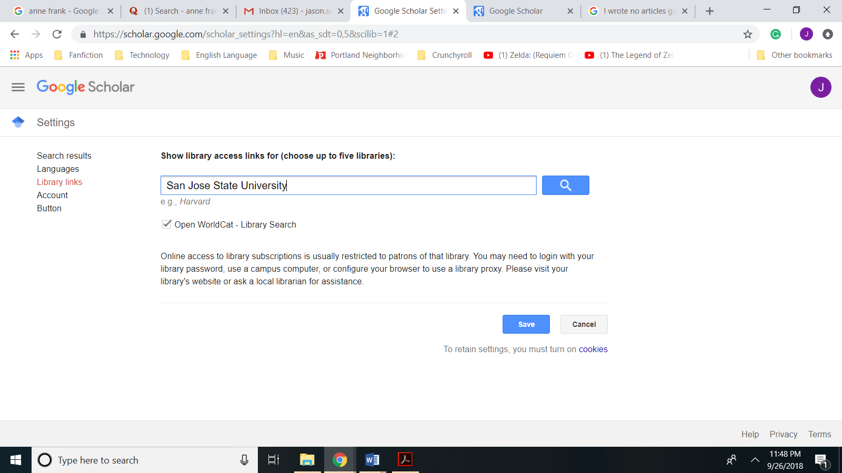

(d) Report your search in Google Scholar search engine and discuss how your search results compared to the other two search engines.

In terms of the number of results returned, the Google search engine retrieved 348,000,000 results. I could not determine how many results the Quora retrieved. The Google Scholar search engine compiled 2,370,000 retrievals. While I was impressed that the Google Scholar search engine’s first two results linked to SJSU’s Martin Luther King Jr. retrieved two whole book length manuscripts relevant to the topic, the remaining first page retrievals were unrelated to life and trials of Anne Frank despite the search results be ordered according to relevance. In comparison, Quora and the Google Search Engine had no difficulty retrieving relevant results. The one area in which, the Google Scholar search engine excelled in comparison to the Quora platform and Google search engine was credibility. Peer reviewed articles are widely considered the most credible sources of information in academia. The retrieval of peer reviewed articles sets Google Scholar apart from either the Quora search engine or the Google search engine.

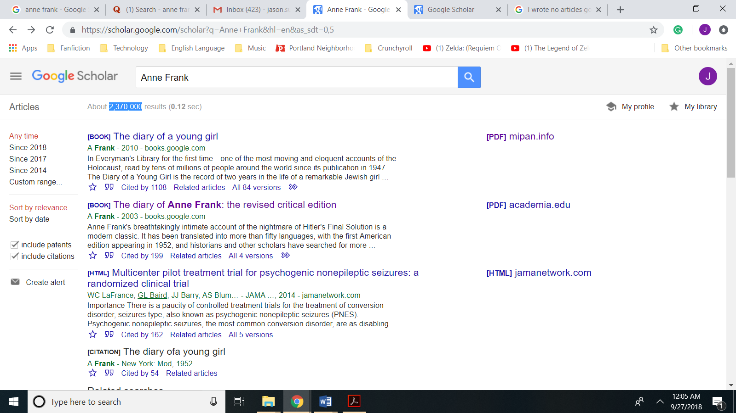

**King Library’s OneSearch Interface**

The King Library moved to a new OneSearch interface that replaced the online catalog. For this question, I would like you to conduct a search in OneSearch on the same topic as used for #4. .   
(a) Provide a screenshot of your search results.   
(b) Compare your OneSearch findings to the same search using Google Scholar in Q4.   
(c) Use the OneSearch filters to narrow your results and provide a screenshot.  
(d) Briefly describe how your filtered OneSearch results compared with your Google Scholar results.

(a) Provide a screenshot of your search results.

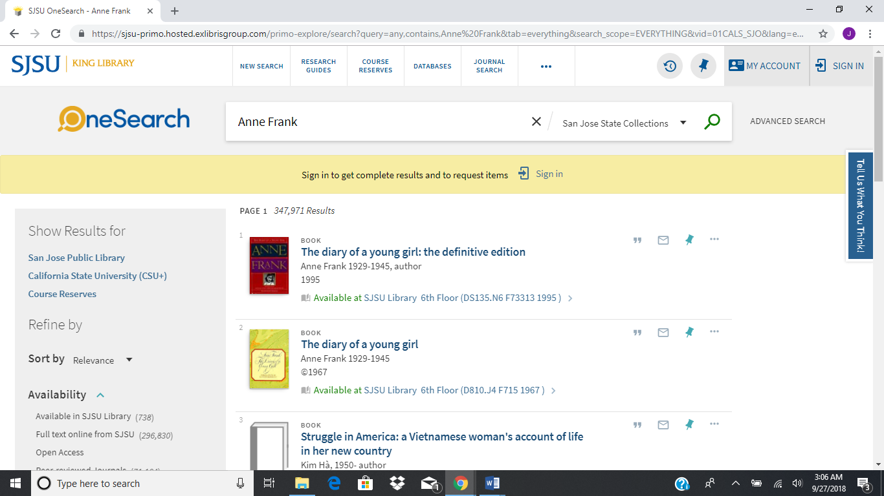

(b) Compare your OneSearch findings to the same search using Google Scholar in Q4.

On the most basic level OneSearch retrieved fewer results for the query Anne Frank—347,971—than the 2,370,000 retrievals found through Google Scholar using the same query. Another difference was the composition of the most relevant results. OneSearch’s most relevant results retrieved far greater number of books, than Google Scholar. In addition, OneSearch’s were relevant to my chosen topic of Anne Frank as opposed to Google Scholar which retrieved peer reviewed articles on subjects unrelated to the life of Anne Frank.

(c) Use the OneSearch filters to narrow your results and provide a screenshot.

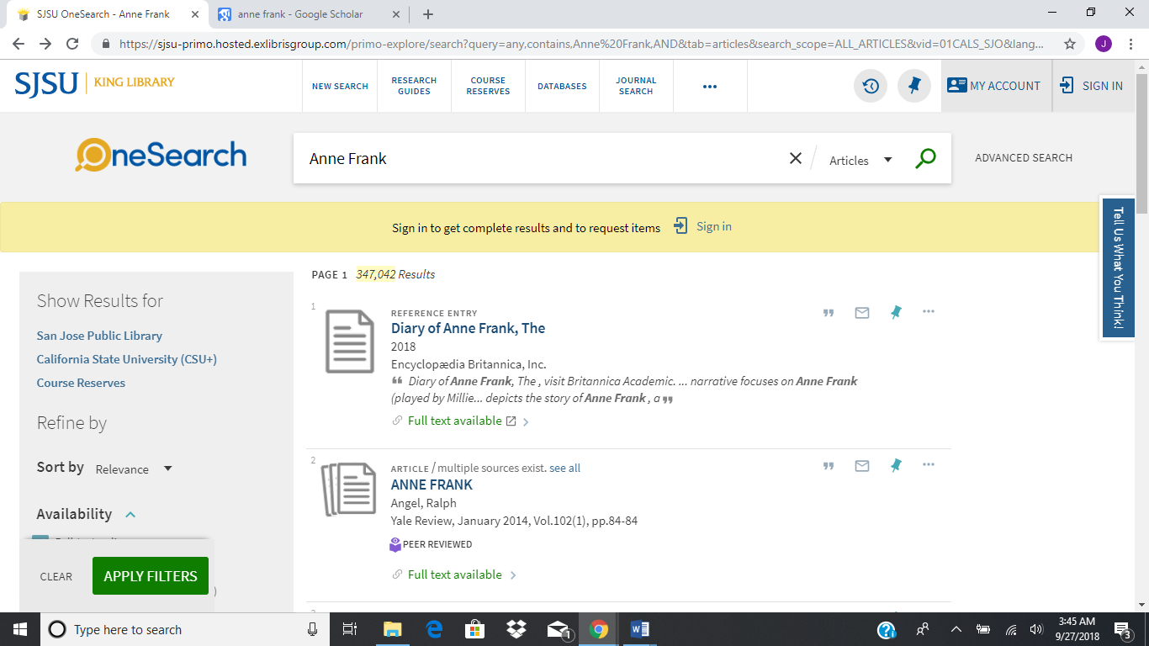

(d) Describe how your filtered OneSearch results compared with your Google Scholar results.

By limiting the OneSearch results by employing the filter “Full-text online” and limiting results only written in English marginally reduced the number of retrievals from 347,971 to 347,042. Most of the results that were eliminated were books. In this way, the filtered OneSearch results for the query Anne Frank more closely matched the results from Google Scholar by emphasizing articles readily available through an online resource.

**Finding Answer and Assessing Authority of Source**

Find an answer to the question

Can you really tell the temperature by listening to the chirping of a cricket?

(a) Assess the authority of your source using criteria such as those discussed by Cassell and Hiremath in the textbook, the criteria posted [by Kent State UniversityLinks to an external site.](http://www.library.kent.edu/criteria-evaluating-web-resources) the ["CRAAP" test,Links to an external site.](http://nova.campusguides.com/evaluate) or [RADCAB (Links to an external site.)Links to an external site.](http://www.radcab.com/)

(b) Because many patrons in the real world are never going to bother looking using librarian checklists, I would like you also to try a [technique recommended by Meredith Farkas (Links to an external site.)Links to an external site.](https://americanlibrariesmagazine.org/2018/06/01/beyond-fake-news/) called["reading laterally. (Links to an external site.)Links to an external site.](https://hapgood.us/2018/03/07/how-to-read-laterally-a-lesson-for-new-york-times-columnists-including-but-not-limited-to-bari-weiss)" Farkas recommends looking into the publisher of the source to gauge its reliability and credibility. This means going beyond just looking at the About page to see what kinds of sources are being cited and what others have to say about the publication in question. You can check sources and verify information using sources such a bias fact checker, check the sources used or verifying sources in other ways. A case in point is verifying the relative merits of a reliable source such as the “American Academy of Pediatrics” and the conservative fringe group “American College of Pediatricians.” Based on what you learn, do you think your web resource is a more reliable method? Why or why not?

(a) Assess the authority of your source using the CRAAP Test.

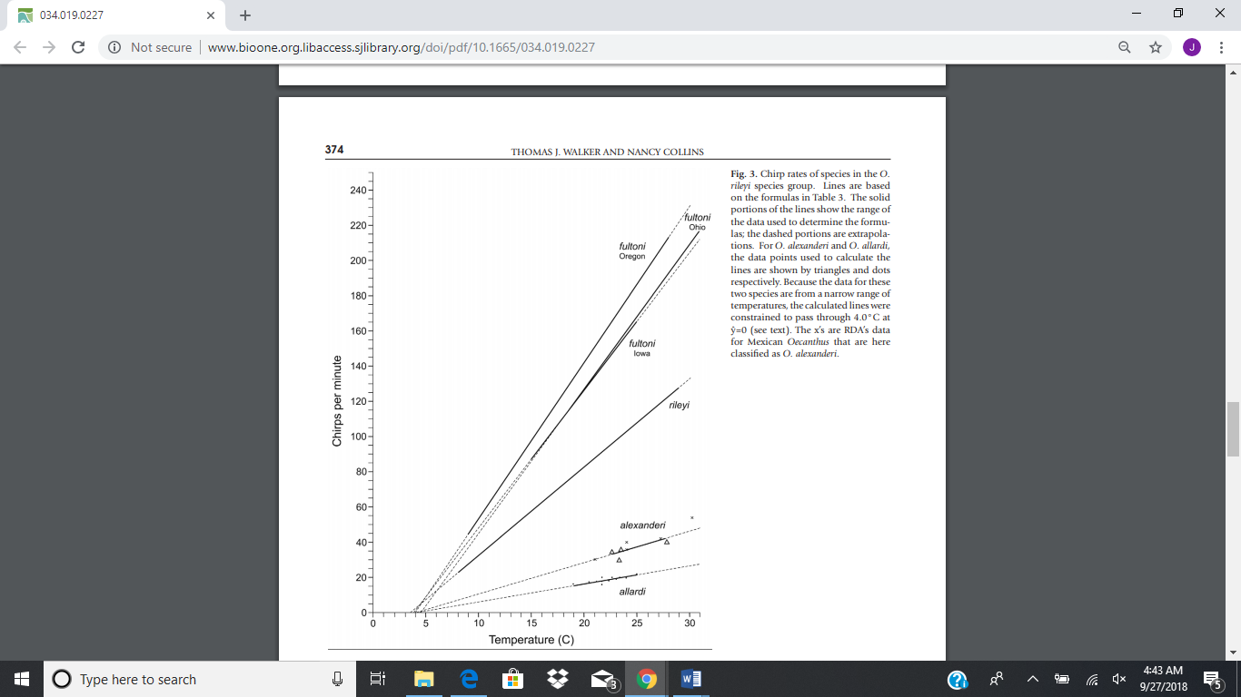

This diagram from the article “New World Thermometer Crickets: The Oecanthus rileyi Species Group and a New Species from North America” from the Journal of Orthoptera Research clearly demonstrates a linear correlation between temperature and the rate that crickets chirp suggesting that it is possible to determine the temperature based on the frequency of a cricket’s chirping with some degree of accuracy.

Currency

While it’s been nearly eight years since the article “New World Thermometer Crickets” has been published, currency is not critical, considering the passage does not invalidate the results in this study or the principles that underline the premise.

Relevancy

The intended audience for this paper is academics who may be called on to use such information to further their research and because this article comes from the peer reviewed Journal of Orthoptera Research (verified by UlrichsWEB Global Services Directory), anyone should be comfortable with citing this source.

Authority

The two authors of “New World Thermometer Crickets: The Oecanthus rileyi Species Group and a New Species from North America” are Thomas J. Walker and Nancy Collins.

While Nancy Collins is listed as an amateur entomologist, Thomas J. Walker has a Ph.D in Entomology from the Ohio State University has the expertise to publish authoritative work on crickets. In addition, this article’s publication through a peer reviewed journal increases the authority of the article’s contents.

Accuracy

“New World Thermometer Crickets: The Oecanthus rileyi Species Group and a New Species from North America” appears to be accurate by providing supportive evidence with no obvious spelling or errors in grammar. In addition, by being subjected to the peer-reviewed process, researchers can conclude that the results are accurate with a reasonable degree of confidence.

Purpose

The purpose of this paper is non-political with its primary indent to inform. There seems to me no obvious bias or intention beyond destination of the articles subject matter.

(b) You can check sources and verify information using sources such a bias fact checker, check the sources used or verifying sources in other ways. Based on what you learn, do you think your web resource is a more reliable? Why or why not?

I already performed a lateral reading by browsing through several websites to track down the qualifications of the listed authors: Thomas J. Walker and Nancy Collins. While the qualifications of Nancy Collins as amateur entomologist do not inspire confidence, Thomas J. Walker publication of additional articles in the field of entomology and his Ph.D. in Entomology from the Ohio State University increases my trust in the article titled “New World Thermometer Crickets: The Oecanthus rileyi Species Group and a New Species from North America.”