**Project 3:  Privateer Press Website Analysis**

Timothy Straus

Jason Sue

Austin Thompson

San Jose State University – School of Library and Information Science

Professor Alyce Scott

INFO 202-16

May 15, 2017

**Table of Contents**

1. Executive Summary…………………………………………………………… p 2
2. Introduction……………………………………...……………..………...…… p 3
3. Site Map of Existing Site & Discussion…………………………….………… p 5
4. Redesigned Site Map & Discussion ………………..……………..………….. p 8
5. Recommendations……………………………….……….………….…...…… p 9
6. References ……………………………………………………………..…..…. p 14

**Executive Summary**

This project aims to develop a better website for the Privateer Press company. The main goal here is to offer the organization a complete re-design of their website in order to improve its navigation and thus lead to a more user-friendly interface. This report starts off with a brief introduction regarding the games that Privateer Press is known for making and the other products associated with those games. Next, there will be two images of separate site maps presented, which will give a clearer understanding of (1) what the website looks like in its current state, and (2) Group 29’s vision for a completely redesigned website for the company’s consideration. After each image is a discussion on the respected site map to further explain the structure being presented. The site maps and the discussions only offer a small percentage of the website, but the carefully selected webpages serve as our greatest examples of what can be changed. Finally, our group’s recommendations are written in greater detail to back up our arguments on the advantages that the changes will have on the organization’s website. Our recommendations are not mandatory for PrivateerPress.com; they only serve as an offer for them to put into action or disregard it entirely.

**Introduction**

This website is for the tabletop war games called Warmachine and Hordes. The game and the company associated with it were created in 2000 by Matt Wilson. The website acts as the face of the game and the company. It has links to the primary products (Warmachine and Hordes) and to additional products such as the Iron Kingdom RPG and Level 7. It is a major community resource, providing access to players to look at upcoming releases and upcoming game changes. The site links to the official forums and also provides resources for new players such as tutorials and a model gallery.

The homepage is plagued with confusing nested menus. Any new players or perspective players coming to the website might find the interface difficult to navigate. Veteran players may also encounter difficulties as some links are buried within menus. In his list of guidelines, Nielsen says that a good web design emphasizes the most important tasks on the site (2002). The Privateer Press site fails in this regard. Many of the important links are nested within other unintuitive links that may make them difficult to find. For example, though the forum page is located logically under the community tab, it should also be quickly accessible without digging through menus.

Another major issue is the search bar. Nielsen’s guidelines say that there should be a search bar on the site (2002). Though Privateer Press has implemented this as part of their design, it is done poorly. The search bar is small and placed off to the top left hand side of the page near the company logo. Due to the colors chosen for the website, the search bar blends with the logo which could make it difficult for users to find. It is also small, making it difficult to read as well.

The page is also extremely disorganized. There is a lot of information being thrown at the user the moment they log into the homepage. While the banner on top does somewhat provide notable updates for the game, some of these links lead to places that have not been updated in over a year. Additionally, many of the social media links on the homepage are not easily identified. The Twitter feed is incredibly small and looks like a jumble of text. Part of our group was completely unaware that there was a link to an Instagram page at all. We aim to improve these issues in hopes to make the Privateer Press website more user friendly.

**Existing Site Map:**All pages are connected to the Homepage on this map EXCEPT for the two pages (All New War! *AND* Lock & Load Gamefest 2017) located on the bottom right.

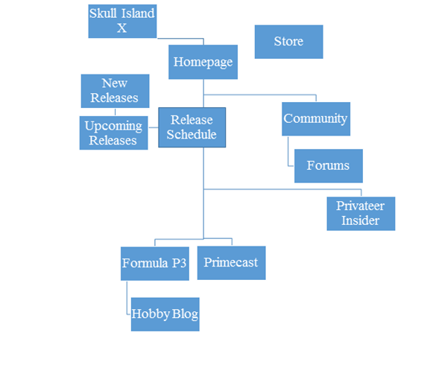

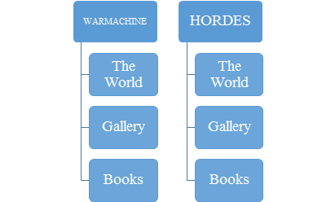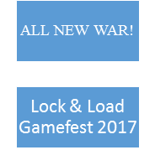

**Discussion of Existing Site Map**

We have put together a site map that represents only a small portion of the entire Privateer Press website. Mapping the entire site would be difficult and is out of scope for this project. Our site map covers only twenty-one pages of the website that we felt were the most important. The site begins at the homepage with the other pages branching off of the homepage at one or multiple junctions.

The site banner links to a couple of pages: the All New War page (referencing a major rule update to the game) and the Lock & Load page (Privateer Press’ main convention). These pages are located on entirely different websites than the Privateer Press site. The “All New War” page is well laid out, but it has not been updated in nearly a year. This brings into question its relevance as a page on the website. Much of this information could be moved elsewhere.

Two branching paths that are similar to one another are the Warmachine and Hordes branches from the main page under the Home menu. Each of these contains game descriptions (the World), a gallery of relevant models (Gallery), and links to books regarding the game (Books). These sections provide a comprehensive look at each game, but they are overwhelmed by the clutter on the homepage. The user’s eye may not be drawn immediately towards them. This could make finding more information about the game difficult for prospective or new users.

The release schedule, located under the Home menu, is another important link for current players. This link is being washed out by the clutter on the main page. However, the main page also links directly to upcoming releases which occupies half of the real estate on the homepage. Another element occupying visual space on the homepage are links to the Privateer Press blog “Insider.” This is useful because it gives a direct link to the most recent news from the company. However, it only links to the most recent blog. To look at other entries in the series, one must navigate to Privateer Press Insider under the community tab. This community menu’s default state is closed, so this link is obscured upon loading the page. There is no way to navigate back to previous entries from a current entry.

The community menu is one of the more important menus in the site map. It contains links to Privateer Press Insider and the various forums used by community members. This menu benefits from keeping all of the community related content in one place. However, its location in the list of menus is far lower than it should be. For such an important portion of the site map, these links should be placed further up on the list of menus. Placing it low makes it difficult to find for users.

The Skull Island X link takes users directly to the Skull Island X webpage. This page is used to sell digital copies of the books written to supplement the lore of the games produced by Privateer Press. This, like the All New War page, is a completely separate website from the Privateer Press main site. Though it does provide information and the layout of the page is far superior to that of the Privateer Press homepage, this page may not be important enough to have a link of its own. It may add clutter to the list of menus on the homepage.

Lastly, we have the links to Primecast and Formula P3. The Primecast page is dedicated to Privateer Press’ podcast. This link appears at the very bottom of the menus on the homepage, and this is actually not necessarily a bad place for it. It would be lost in the middle of these menus, so placing it at the bottom could make it easier to spot. The podcast is also a community resource like the Insider blog, yet it does not appear under the Community menu where it might be more logical to place it. The Formula P3 menu links to the hobby blogs and the Privateer Press line of paints. This has the advantage, as with the community menu, of keeping all of the hobby related aspects of the game located in one place. However, the Hobby Blog page is under-utilized with very few updates in recent years. There have only been three updates in the last year. Due to the lack of updates, it is questionable whether this page might be removed to reduce clutter.

**Redesigned Site Map:**The only separate webpage on this map is the Level 7 page on the top left corner.  The rest of the pages are all connected to the homepage and modified for easier findability and navigation.

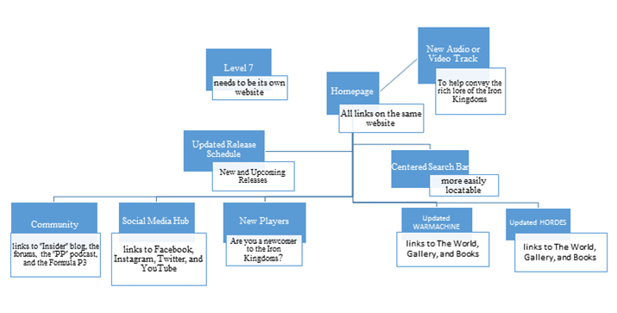

**Discussion of Redesigned Site Map**

Our revised site map strives to showcase a more orderly and organized Privateer Press website. Some of the pages featured on the original site map have now been grouped together based on relevance. For example, the Community tab now includes their podcast (aka Primecast) instead of it being located at the bottom of the menu bar on the homepage. Likewise, all the social media links are to be grouped together in a single menu instead of being scattered all over the place. The goal of grouping similar webpages into one big menu will drastically help decrease the disorganized clutter currently happening on the homepage. Also, a new section should be created to help guide new users to the lore of the Iron Kingdoms and the mechanics of the game. The link should be titled “New Players” to avoid any confusion among the newcomers of the website. Lastly, the search bar should be moved to a more central location on the main page instead of being unutilized at the very top left of the screen. A different color scheme separate from the main background of the homepage will increase the likelihood of it being seen. A great “interface design is pivotal to the effective use of an information website” (Chowdhury, 2010, p. 270). But in the case of our study, a tabletop gaming website to be exact.

**Recommendations**

Privateer Press spreads out its content across over multiple websites. Group 29’s small sample of the content is spread across three different websites:<http://privateerpress.com/>, <http://www.allnewwar.com/>,  and <https://www.regonline.com/registration/Checkin.aspx?EventID=1888760&>.

The majority of the content takes place within the Iron Kingdom universe; and to be fair, there is a lot to discuss. The Warmachine and Hordes factions have complex mechanics, and each has their own unique rich history. This tapestry of lore is the foundation for the current balance of power within Iron Kingdoms. Challenges to that power form the basis of the WarMachine or Hordes tabletop war games. Group 29 recommends that all of the Iron Kingdom content be centralized into one website to enhance navigation and to move the Level 7 content to its own unique website.

As demonstrated by the site map, Privateer Press’s homepage is broad containing a rotating slideshow, a menu bar on the left side of the webpage, a search engine, and posts of recent and not so recent developments. The menu bar itself is rather cluttered. While the menu bar contains links to a total of 46 webpages some of these links are nested inside dropdown menus. Unfortunately in the first level of the menu bar, these links and nested dropdown menus are indistinguishable from each other. This makes navigation unnecessarily tricky. Group 29 recommends that Privateer Press enhance the menu bar by leaving an indication of when a button on the menu is actually a nested dropdown menu instead of a link. This indication could be something as simple as a small arrow.

Between the menu bar, the slideshow, and the 22 posts displayed on May 10, 2017 of some recent and some not so recent content, the homepage needs to reduce the clutter. It is simply too busy!

To help reduce the clutter, Group 29 recommends that the Privateer Press homepage be rebranded to a Iron Kingdoms homepage. Tim Straus, who is an Iron Kingdom player, says that that Privateer Press does not have the reputation, popularity, or name recognition to improve the marketability of its products by simply attaching its name to said products. With the difficulty of outsiders have in grasping the concept of Hordes or the concept of Warmachine and how the two factions compete with each other, Privateer Press should reduce the prominence of the company and focus more on the individual gaming products.

In addition to rebranding the homepage, Group 29 recommends that they consider another color scheme. Currently the layout of each webpage is dominated with various shades of black, with red text for headings and white text for the body. This color scheme is taxing on the eyes making extremely difficult to differentiate between different elements of each webpage. We recommend some user testing to test other color schemes. One recommendation is for Privateer Press to adopt a steampunk-esque style and make use of the various shades of metal from brown-red rust, to metallic gray, to chromium gold.

One of the weaknesses of hierarchical classifications that users trying to drill down to a specific fact could get lost in an overly broad hierarchy (Weedman, Lecture 8, p. 18). Thankfully, Privateer Press uses a search box, but we suggest moving the search bar down since it is difficult to see it in the top right corner.

In addition, Privateer Press needs to develop more discipline when interacting with their own gaming community and the public at large. The homepage acts as a catch all to developments that pertain to the company in Privateer Press. In particular, featuring press releases on the homepage is particularly bad form. One such press release found on the homepage is <http://privateerpress.com/press-releases/privateer-press-discontinues-packaged-stat-cards>. Press releases should be mailed directly to the relevant media outlets. Communicating with Privateer Press’s fan community through a press release is impersonal and leaves an impression that the company does not care enough to personalize their communications. Press releases have no business on any homepage.

To improve communication with the gaming community, Group 29 recommends that Privateer Press centralize the company’s social media activity into a single web portal. This includes Privateer Press’s Twitter feed, Facebook page, Instagram album, and YouTube channel. This will facilitate interactions within the gaming community with respect to the Iron Kingdoms intellectual property by providing a reliable avenue where players and fans can learn about and comment on recent developments for either the Hordes or the Warmachine factions.

Group 29 attempted to critique and recommend changes to the website for the Warmachine and Hordes tabletop. While the Privateer website is particularly poorly designed, Group 29 members Austin Thompson and Jason Sue had an especially difficult time assessing the subject matter as they were both new to Warmachine and Hordes. Through their personal exploration of the website both Austin and Jason came to the conclusion that the Privateer Press homepage does a poor job of explaining either Warmachine or Hordes to newcomers. As a business, Privateer Press should be greatly concerned that their website acts as a barrier to attracting new customers. Group 29 recommends that Privateer Press’s homepage highlights a link that leads to a redesigned “new players” section. Such a link could be phrased conversationally such as in the phrasing “Are you a newcomer to the Iron Kingdoms?”

Overall the design of the whole website feels lazy. While Group 29 appreciated the rotating slide show at the top of their homepage, we were dismayed that it lacked the richness that is now possible through multimedia content. Video and audio should be used to convey the rich lore of the Iron Kingdoms universe. At a bare minimum, the homepage should feature a flash video. In this day and age, it is completely unacceptable for one of tabletop gaming’s leading companies to have such amateurish website.

Collectively, Group 29’s recommendations amount to a complete redesign of the website. Because of the scope of the changes Group 29 is proposing, Group 29 also recommends that Privateer Press should consider starting from scratch. In either case, Privateer Press should consult with a web design firm as the company clearly lacks the expertise required to design a professional webpage. Whether Privateer Press chooses to redesign the website or start from scratch, extensive requirement analysis is needed to ensure that the considerable expenditure of resources is not wasted (Weedman, Lecture 4, p. 7). When analyzing this website, there is no doubt in the minds of Group 29 that Privateer Press’s website was created on the assumption that the company already understood the online behavior of their fan community. The result of such hubris is plain to see. There are several techniques that Privateer Press could employ for its requirements analysis. Some methods include card sorting, surveys, interviews, focus groups, and participant observation. We also recommend that Privateer Press look at their chief rival’s website (<https://warhammer40000.com/>) for a greater understanding on how a website can better connect with the gaming community. During the overhaul of Privateer Press’s online presence, it would be prudent for Privateer Press to keep its existing collection of websites running while they develop their future website. During such development they should alpha test the concept and beta test the prototype using a cross section of their likely users—always taking into account the feedback from such testing in the next stage of development.

To recap, Privateer Press’s website is poorly designed and poorly managed. Some of the recommendations that Group 29 made are structurally significant including the recommendation to center Iron Kingdoms material into one website while other recommendations are more cosmetic such as the relocation of Privateer Press’s search engine so that it can be more easily spotted. To achieve these improvements, extensive user testing will be required to attain a website that matches the needs and online behaviors of their users: the gaming community of the Iron Kingdoms.

**References**

Chowdhury, G. G. (2010). *Introduction to modern information retrieval, 3rd edition.* London, England: Facet Publishing.

Nielsen, J. (2002). Top 10 guidelines for homepage usability. Retrieved from <https://www.nngroup.com/articles/top-ten-guidelines-for-homepage-usability/>

Weedman, J. (2015, January). Lecture 8: Designing for navigation: Web site structures and classifications systems [pdf].

Weedman, J. (2015, February). Lecture 4: The Design Process [pdf].